An Engineering Framework for Non-Timing Detection Resistance in Proxy Traffic
/ A Measurement-Guided Adaptive Framework for Proxy-Traffic Detection-Confidence Reduction/
In this PRAXIS, non-timing refers to detection features that do not rely on packet inter-arrival timing or fine-grained latency behavior. PRAXIS focuses on non-payload traffic-shape features, including packet counts, directional byte counts, burst structure, signed packet-length sequences, and aggregate flow duration. Because aggregate flow duration is included in some analyses, additional artifact-control tests are performed without duration features to verify that the observed mechanism is not solely timing-derived.
PRAXIS started as a controlled proxy-traffic detectability experiment. The early results showed that static browser camouflage and static multiplexing were not enough. Most original configurations were detected. Instead of treating that as a failure, I converted the project into a stronger Engineering–level applied cyber analytics contribution. Experiment implemented on Amazon Web Services, documented by phases and artifacts stores on S3 (Amazon Simple Storage Service).
Dataset/artifacts https://drive.google.com/drive/folders/1hTn9yTiuDVH1GMYW1gpBD0L_HLv_5gx0?usp=sharing

RQ1: To what extent do browser-profile and proxy-configuration choices reduce non-timing proxy-detection confidence while preserving session compliance?
result — Confirmed with boundary. Browser camouflage alone did not solve detection, but the selected proxy configuration default_c2_p1 reduced detector confidence while preserving compliance.
RQ2: How do multiplexing mode and browser-side parallelism affect proxy-traffic identifiability under non-timing traffic analysis?
result — Confirmed/mechanism supported. The strongest evidence points to c2 multiplexing with parallelism set to 1 as the main traffic-shape mechanism.
RQ3: Can the best traffic-camouflage configuration be integrated with decentralized resolution to preserve access and compliance under DNS-blocking conditions?
result — Confirmed at controlled resolver-independence level. Standard DNS succeeded, DNS-blocked mode failed, and decentralized-style local resolution succeeded.

Methods before Phase 34 – Inferential stat in Praxis. 3
Cycle 1 13
Phase 1 — Project documentation and research framing 13
Phase 2 — AWS lab validation 13
Phase 3 — Tooling 14
Phase 4 — Pilot experiments 15
Phase 5 — RQ1 formal experiment: browser/profile camouflage 16
Phase 6 — RQ2 formal experiment: multiplexing 16
Phase 7 — RQ3 formal experiment: DNS/decentralized-resolution setup 16
Phase 8 — Feature extraction 17
Phase 9 — Detector and statistical summary: Initial detector 17
Phase 10 — Baseline preservation 18
Cycle 2 begins: the novel part - Adaptive Controller Work 18
Phase 11 — Public dataset ingestion 18
Phase 12 — Public benign feature model 19
Phase 13 — Candidate configuration sweep 19
Phase 14 — Initial controller scoring and correction. 20
Phase 15 — First confirmatory rerun 20
Phase 16 — Targeted C2 candidate expansion 21
Phase 17 — Out-of-sample confirm-best rerun 21
Intermediate analysis: Phase 10 - 17 23
Where the novelty is: 24
Phase 18 — Mechanism analysis 26
Phase 19 — External public-benign validation (Second MAWI dataset baseline) 26
Phase 20 — Holdout detector robustness 26
Phase 20B — Threshold validation 27
Phase 21 — RQ3 resolver-independence integration 28
Phase 22 — Figures and tables 29
Phase 23 — Chapter writing package 30
Phase 24 — PRAXIS Controller Service 30
Phase 25 — PCAP Analyzer Web App 30
Phase 26 — GitHub release 30
Phase 27 — Streamlit Cloud deployment 31
Intermediate analysis #2: Phase 11 - 27 31
Cycle 3 35
Phase 28 — AMI clone validation 35
Phase 29 — Upgrade 1: Mechanism analysis 35
Phase 29B — Artifact-control mechanism check 37
Phase 30 — Upgrade 2 and 7: Multi-detector robustness 37
Phase 31 — Upgrade 3: MAWI + CICIDS public-baseline sensitivity 38
Phase 32 — Upgrades 6 and 8: Formal algorithm, threat model and reproducibility 38
Phase 33 — Upgrade 9: GitHub update and artifacts 40
What PRAXIS should claim now 40
Why this is strong for D.Eng defense 40
Phase 34 inferential-statistics layer 41
PRAXIS Adaptive Camouflage Controller Studio 43
GLOSSARY 48

Methods before Phase 34 – Inferential stat in Praxis.
Before inferential testing, PRAXIS calculated results through a controlled engineering evaluation pipeline. Each configuration was executed across repeated sessions, packet captures were transformed into PRAXIS traffic-shape features, detector models produced session-level proxy probabilities, public-benign distances were computed from MAWI-derived reference distributions, and configurations were ranked using a corrected multi-objective PRAXIS score incorporating detector confidence, public-distance, overhead, and compliance. Candidate discovery was separated from out-of-sample confirmation. Additional robustness layers included fresh holdout detectors, threshold-calibrated detection analysis, controlled resolver-mode success testing, feature-level mechanism analysis, multi-detector evaluation, and public-baseline sensitivity analysis.

Phase 34 added session-level inferential statistics to quantify uncertainty around these measured effects.

PRAXIS results were calculated through engineering measurement, feature extraction, detector scoring, public-baseline distance scoring, aggregation, confirmatory reruns, and robustness/sensitivity checks. Phase 34 - added a formal inferential-statistics layer on top of results that were already calculated.
PRAXIS used these methods:
1. Controlled repeated lab sessions
2. Packet capture and session logging
3. PRAXIS traffic-shape feature extraction
4. Detector probability scoring
5. Public-benign robust distance scoring using MAWI
6. Overhead and compliance scoring
7. Corrected multi-objective PRAXIS score
8. Configuration-level aggregation by mean/std
9. Out-of-sample confirmatory reruns
10. Fresh holdout detector evaluation
11. Threshold-calibrated detection-rate checks
12. Controlled resolver-mode success counting
13. Mechanism analysis with feature deltas, feature importance, and ablation
14. Multi-detector robustness testing
15. Public-baseline sensitivity with MAWI + CICIDS

Phase 34 then added:

- bootstrap confidence intervals
- permutation tests
- Mann–Whitney tests
- Cohen’s d
- Cliff’s delta
- Wilson confidence intervals
- Fisher exact tests
- Benjamini–Hochberg correction

So the difference is: Before Phase 34: PRAXIS calculated measured effects, scores, rankings, robustness, and sensitivity.
Where Phase 34: PRAXIS quantified statistical uncertainty and significance around those effects.

1. Controlled repeated-session method
Before any scoring, PRAXIS used repeated controlled sessions.
Each configuration was run multiple times:
Phase 13: 80 sessions
Phase 15: 90 sessions
Phase 16: 160 sessions
Phase 17: 150 sessions
Phase 21: 90 RQ3 sessions
The basic experimental unit was: one session
Each session had:

session_id
config_id
success label
pcap file
browser/curl log
traffic-shape features
detector probability
public-distance score
overhead score

This method allowed PRAXIS to compare configurations based on repeated observations rather than one-off examples.
Important point: Packets were used to build features, but sessions were the actual experimental units.

2. Packet capture and session logging method
PRAXIS generated traffic under controlled configurations and captured it with tcpdump.
The raw collection sources were:

pcaps
browser logs
curl logs
tcpdump logs
sweep catalogs
configuration files

These were not the final result by themselves. They were raw evidence.
The raw data were transformed into structured session-level CSVs.
Example flow:
pcap + session log
→ feature extraction
→ session feature row
→ detector scoring
→ public-distance scoring
→ PRAXIS score
→ config-level result
This is how raw traffic became measurable data.

3. PRAXIS traffic-shape feature extraction method
Before Phase 34, your main quantitative method was traffic-shape feature extraction.
From each pcap, PRAXIS extracted features such as:

pcap_size_bytes
packet_count
out_packets
in_packets
unknown_packets
out_payload_bytes
in_payload_bytes
total_payload_bytes
flow_duration_seconds
burst_count
len_1 through len_20

The signed length features used direction:
positive length = outbound/client-to-server
negative length = inbound/server-to-client
zero = unknown or absent
Example:
len_1 = 1460
len_2 = -1200
means:
first packet: outbound payload length 1460
second packet: inbound payload length 1200
This feature extraction method gave PRAXIS a common schema for:
lab sessions
MAWI public traffic
PCAP Analyzer uploads
CICIDS mapped baseline

4. Direction-normalization method
For lab pcaps, direction was based on the known client IP.
The idea was:
source = client IP → outbound packet
destination = client IP → inbound packet
otherwise → unknown
For public traffic, direction was approximated using service-port heuristics where possible.
If direction was ambiguous, PRAXIS fell back to first-observed source as the positive direction.
This mattered because many PRAXIS features depend on direction:
out_packets
in_packets
out_payload_bytes
in_payload_bytes
signed packet lengths
burst_count

5. Detector probability scoring method
Before Phase 34, the main detector result was calculated using model probability scores.
The detector output was:
detector_proxy_probability
Meaning:
probability that the session looks like proxy/circumvention traffic
Interpretation:
0.0 = low detector confidence
1.0 = high detector confidence
The detector scoring method was:
session features
→ trained detector
→ predict_proba
→ detector_proxy_probability
Then PRAXIS computed configuration-level averages:
mean_detector_proxy_probability
The main Phase 17 result was calculated as:
baseline_default_off mean detector probability = 1.000
default_c2_p1 mean detector probability = 0.487
detector_delta = 0.487 - 1.000 = -0.513
Before Phase 34, this was a measured mean difference. Phase 34 later added confidence intervals and p-values.

6. Public-benign distance method using MAWI
PRAXIS used MAWI as the primary public-benign reference.
The purpose was to prevent the controller from selecting a configuration that only reduces detector confidence but becomes obviously abnormal compared with public benign traffic.
The method was:
PRAXIS session features
MAWI public benign features
→ transform features
→ compute robust distance from public benign baseline
The feature transform was essentially:
signed_log(x) = sign(x) * log(1 + abs(x))
Then PRAXIS compared session features against public baseline medians and IQRs:
z = (session_feature - public_median) / public_IQR
Then distance was calculated as a vector distance:
public_distance = sqrt(sum(z_i^2))
This produced:
public_robust_log_distance
public_robust_log_distance_norm
Important correction from Phase 14B:
pcap_size_bytes was removed from public-distance scoring.
pcap_size_bytes was kept as overhead instead.
That correction was necessary because pcap size behaved differently in MAWI sample files and PRAXIS per-session captures.
Before the correction, public-distance scoring was distorted.
After the correction, public-distance became more defensible.

7. Overhead scoring method
PRAXIS separately measured overhead.
The main overhead feature was:
pcap_size_bytes
or normalized pcap/session size.
The goal was:
penalize configurations that reduce detector confidence only by adding too much traffic or cost
Typical overhead method:
overhead_norm = normalized pcap size or normalized traffic cost
Interpretation:
lower overhead_norm = better
higher overhead_norm = more costly
This mattered because some camouflage approaches can reduce detector confidence by adding excessive traffic, which is not desirable.

8. Compliance scoring method
PRAXIS included a success/compliance label:
success = 1
failure = 0
Configuration compliance was calculated as:
mean_success = successful sessions / total sessions
Compliance penalty was calculated conceptually as:
compliance_penalty = max(0, threshold - mean_success)
The threshold was commonly: 0.95
Meaning: configurations below 95% compliance should be penalized
For your final Phase 17 configurations:
baseline_default_off: 50/50 success
camouflaged_c2_p1: 50/50 success
default_c2_p1: 50/50 success
Before Phase 34, this was reported as descriptive success counts and success rates. Phase 34 later added Wilson confidence intervals.

9. Corrected PRAXIS score method
The main PRAXIS controller result was calculated with a corrected multi-objective score.
The score combined:
detector probability
public-benign distance
overhead
compliance penalty
Conceptually:
PRAXIS score =
w_detector * detector_probability
+ w_public * public_distance_norm
+ w_overhead * overhead_norm
+ w_compliance * compliance_penalty
Lower score is better.
Default weight pattern was approximately:
detector weight = 45%
public weight = 35%
overhead weight = 5%
compliance weight = 15%

These weights define the default PRAXIS scoring policy. They reflect the research priorities of the controller and are adjustable in the app for sensitivity analysis.

The default PRAXIS score uses a weighted multi-objective policy with 45% detector probability, 35% public-benign distance, 5% overhead, and 15% compliance penalty. These weights reflect the controller’s research priorities. Detector confidence receives the largest weight because reducing proxy-detector confidence is the primary objective. Public-benign distance receives the second-largest weight because selected traffic should remain constrained by an external benign traffic envelope. Compliance is treated as a guardrail so that configurations that fail sessions are penalized or rejected. Overhead is included as a smaller cost term to prevent traffic inflation from dominating the selected configuration. The weights are not claimed as universally optimal; they define the default PRAXIS scoring policy and can be adjusted for sensitivity analysis.

The Phase 17 result was:
baseline_default_off score = 0.654073
default_c2_p1 score = 0.432949
score_delta = -0.221124
Interpretation before Phase 34:
default_c2_p1 had a better measured multi-objective score than baseline.
Interpretation after Phase 34:
the score improvement was also statistically stable under bootstrap resampling.

10. Configuration-level aggregation method
Before Phase 34, most results were calculated by grouping sessions by configuration.
Example:
group by config_id
compute:
n
mean_success
mean_detector_proxy_probability
mean_public_distance
mean_overhead
mean_score
standard deviation
This produced tables such as:
phase17_confirm_config_scores.csv
phase20_holdout_detector_config_scores.csv
phase30_multidetector_config_scores.csv
phase31_mawi_cicids_rescored_configs.csv
This was the main descriptive-statistical method before Phase 34.

11. Delta versus baseline method
PRAXIS compared each candidate to the baseline.
The basic formula was:
delta_vs_baseline = candidate_mean - baseline_mean
For detector probability:
default_c2_p1 detector delta = 0.487 - 1.000 = -0.513
For score:
default_c2_p1 score delta = 0.432949 - 0.654073 = -0.221124
Interpretation:
negative detector delta = lower detector confidence
negative score delta = better PRAXIS score
This delta method was used throughout:
Phase 15
Phase 16
Phase 17
Phase 20
Phase 30
Phase 31
Before Phase 34, the deltas were measured differences. Phase 34 later added uncertainty estimates.

12. Candidate sweep method
PRAXIS did not test only one configuration.
It used sweeps:
Phase 13: broad candidate sweep
Phase 16: targeted c2/parallelism expansion
Phase 17: confirm-best rerun
The method was:
define candidate configurations
run repeated sessions per config
extract features
score each session
aggregate by config
rank configs
select best candidate
confirm out of sample
This is central to the adaptive-controller method.
It prevented PRAXIS from being a one-off result.

13. Confirmatory rerun method
PRAXIS separated: discovery
from: confirmation
Phase 16 discovered strong c2_p1 candidates.
Phase 17 confirmed them out of sample.
This is why Phase 17 is your main result phase.
Before Phase 34, the confirmatory result was calculated as:
50 sessions per final configuration
mean detector probability
mean score
success rate
delta vs baseline
Phase 34 then added inferential statistics to those Phase 17 session-level results.

14. Fresh holdout detector method
Phase 20 added fresh detector robustness.
The method was:
train new detector using earlier PRAXIS proxy sessions
use MAWI public benign features as negative class
exclude Phase 17 confirmatory sessions from training
evaluate Phase 17 sessions
compare baseline vs default_c2_p1
Two modes were used:
strict_unseen
baseline_known
Results:
strict_unseen:
baseline = 0.959737
default_c2_p1 = 0.666053
delta = -0.293684

baseline_known:
baseline = 0.998023
default_c2_p1 = 0.663093
delta = -0.334930
Before Phase 34, these were descriptive holdout-detector deltas. Phase 34 later added bootstrap CIs and p-values.

15. Threshold calibration method
Phase 20B checked whether detector-confidence reduction became binary bypass.
The method was:
use public benign holdout data
choose thresholds for target public false-positive rates
apply thresholds to PRAXIS sessions
calculate detection_rate_at_threshold
This produced:
phase20b_threshold_validation.csv
The purpose was to distinguish:
confidence reduction
from:
binary detection bypass
Result:
confidence reduction was supported
complete binary bypass was not supported
This is one of the most important claim-boundary methods.

16. RQ3 resolver success-count method
Phase 21 tested resolver behavior.
The method was:
run hostname-based sessions under three resolver modes
count success/failure
compute success rate
Modes:
standard_dns_lab
dns_blocked
decentralized_resolution
Results:
standard_dns_lab: 30/30 success
dns_blocked: 0/30 success
decentralized_resolution: 30/30 success
Before Phase 34, this was a success-count and success-rate result. Phase 34 later added Wilson confidence intervals and Fisher exact tests.

17. Mechanism analysis method before Phase 34
Phase 29 explained why default_c2_p1 worked.
Methods used:
feature mean differences
percent deltas
Cohen’s d
Mann–Whitney p-values
logistic mechanism model
random forest mechanism model
feature importance
permutation importance
feature-group ablation
Major feature changes:
flow_duration_seconds: -83.52%
packet_count: -21.85%
out_packets: -23.49%
in_packets: -20.15%
burst_count: -21.45%
Phase 29 showed that baseline and default_c2_p1 were strongly distinguishable:
logistic_auc = 1.000000
random_forest_auc = 1.000000
This was not the main detector-bypass test. It was a mechanism test.
It answered: What changed in the traffic shape?

18. Artifact-control method before Phase 34
Phase 29B tested whether the mechanism was only caused by obvious artifacts.
The method was:
remove duration
remove packet counts
remove duration and packet counts
test payload-only features
test signed-length-only features
test burst-only feature
evaluate separability
Results:
no_duration AUC = 1.000000
no_packet_counts AUC = 1.000000
no_duration_no_counts AUC = 1.000000
payload_only AUC = 1.000000
signed_lengths_only AUC = 1.000000
burst_only AUC = 0.993400
This method supported:
the mechanism is not only duration
the mechanism is not only packet count
the mechanism is not only pcap size
this was mechanism evidence, not a bypass claim.

19. Multi-detector robustness method before Phase 34
Phase 30 tested multiple detector families.
Methods used:
train multiple detector families
score Phase 17 sessions
compare mean probabilities
calculate delta vs baseline
calculate detection_rate_050
calculate bootstrap CI and permutation p-values inside Phase 30
Detector families:
logistic regression
random forest
extra trees
gradient boosting
calibrated linear SVC
Results:
random_forest: delta = -0.381856

extra_trees: delta = -0.156160

linear_svc_calibrated: delta = -0.009679

gradient_boosting: delta = -0.000287

logistic: delta = +0.000482
Interpretation:
detector-family-dependent confidence reduction
strongest under tree-based detectors
not universal
Phase 30 already had some inferential elements, but Phase 34 unified inferential reporting across the whole dissertation evidence set.

20. Public-baseline sensitivity method before Phase 34
Phase 31 tested whether default_c2_p1 remained strong across public baselines.
Methods used:
map CICIDS2017 benign rows into PRAXIS-compatible features
sample/balance MAWI and CICIDS baselines
recompute public-distance
recompute PRAXIS score
rank configurations under each baseline
compare score delta vs baseline
Baselines:
mawi_day1
mawi_day2
mawi_day1_day2
cicids2017_mapped
mawi_plus_cicids_balanced
Result:
default_c2_p1 won under all tested baselines
Score deltas:
cicids2017_mapped: -0.301184
mawi_day1: -0.220701
mawi_day1_day2: -0.222451
mawi_day2: -0.220496
mawi_plus_cicids_balanced: -0.255280
Interpretation:
public-baseline sensitivity supports default_c2_p1 as the best tradeoff configuration
Boundary:
MAWI is primary
CICIDS is secondary mapped sanity check

21. App/service calculation method before Phase 34
The PRAXIS app used the same scoring logic.
The Controller tab calculated:
adjusted_score =
detector_weight * detector_probability
+ public_weight * public_distance
+ overhead_weight * overhead
+ compliance_weight * compliance_penalty
The PCAP Analyzer calculated:
traffic-shape features
public distance
overhead
compliance
partial score if no detector probability
full score if detector probability is supplied
This was an engineering implementation of the methodology.
It was not a new statistical test.

22. What Phase 34 changed
Before Phase 34, results were already calculated using:

means
deltas
standard deviations
config rankings
detector probabilities
success rates
public-distance scores
model outputs
feature deltas
AUC values
sensitivity comparisons

Phase 34 added a unified inferential layer:

bootstrap CIs
permutation p-values
Mann–Whitney tests
Cohen’s d
Cliff’s delta
Wilson CIs
Fisher exact tests
BH-adjusted feature p-values

So Phase 34 answered and It added statistical support.
How statistically stable are the already-measured PRAXIS effects?

Cycle 1

Phase 1 — Project documentation and research framing
The original framing focused on evaluating whether proxy traffic could resist non-timing fingerprinting. The scope excluded payload inspection, user deanonymization, human subjects, and real-world in-country deployment.
Purpose:
Create a controlled AWS lab for measuring proxy detectability, compliance, and censorship-resilience behavior.
What went well:
Created and kept a bounded, ethical lab scope.
Separated detection measurement from deployment claims.
What was weak:
The initial framing was more of an evaluation framework than a novel solution.

Phase 2 — AWS lab validation
I used multiple instances because the project evolved from baseline measurement into iterative engineering and then into reproducibility/upgrade work.
Purpose:
Build a controlled lab where traffic generation, proxy transport, destination service, DNS behavior, and packet capture could be isolated.
The original lab contained separate roles:
controller
client
proxy
destination
DNS/resolution node
The reason for separate roles was to create a controlled lab where traffic generation, proxying, destination response, DNS behavior, packet capture, and analysis could be isolated and measured.
Built the PRAXIS AWS lab with the main instances:
praxis-controller 10.42.1.200
praxis-proxy 10.42.1.42
praxis-client 10.42.1.9
praxis-destination 10.42.1.32
praxis-dns 10.42.1.218

What went well:
The lab had stable TCP reachability.
Proxy and destination services were reachable.

NOTE:
Later created on phase 11: praxis-client-cycle2 10.42.1.43 as a clone of the original PRAXIS client because the first ten phases produced baseline evidence that needed to be preserved.
Cycle 2 (phase 11) introduced major new components:
public-benign MAWI baseline
adaptive controller scoring
candidate sweeps
confirmatory reruns
fresh detector robustness
Streamlit/FastAPI app
PCAP Analyzer
GitHub release

The reason for praxis-client-cycle2:
Protect the original Phase 1–10 baseline.
Run Cycle 2 work without damaging the original evidence.
Keep a clean provenance line from original negative results to adaptive-controller solution.

Then on phase 28 created praxis-client-upgrade1 10.42.1.156 from an AMI (Amazon Machine Image) of praxis-client-cycle2.
This was the correct engineering decision because I needed a safe place for the defense-readiness upgrades:
Phase 28: AMI clone validation
Phase 29: mechanism analysis
Phase 29B: artifact-control mechanism check
Phase 30: multi-detector robustness
Phase 31: MAWI + CICIDS public-baseline validation
Phase 32: formal algorithm, threat model, reproducibility appendix, final upgraded claim
AWS describes an AMI as the image needed to set up and boot EC2 (Elastic Compute Cloude) instances, including software and block-device mapping, and notes that one AMI can be used to launch multiple instances with the same configuration. That is exactly why the AMI clone was useful here: it preserved /opt/praxis, the Python environment, data, scripts, reports, app code, and GitHub export. https://docs.aws.amazon.com/AWSEC2/latest/UserGuide/AMIs.html
AWS also documents that creating an AMI from an instance preserves the customized instance state so it can be used to launch new instances with those customizations. By default, EC2 reboots/powers down to create a consistent image, and AWS warns that skipping reboot can risk file-system integrity. That is why the upgrade clone was safer than continuing experiments directly on the confirmed Cycle 2 machine. https://docs.aws.amazon.com/AWSEC2/latest/UserGuide/creating-an-ami-ebs.html

The reason for praxis-client-upgrade1 was:
Preserve praxis-client-cycle2 as the confirmed Cycle 2 result machine.
Use praxis-client-upgrade1 for final mechanism, robustness, baseline-sensitivity, and defense packaging.
Avoid corrupting or overwriting confirmed artifacts.

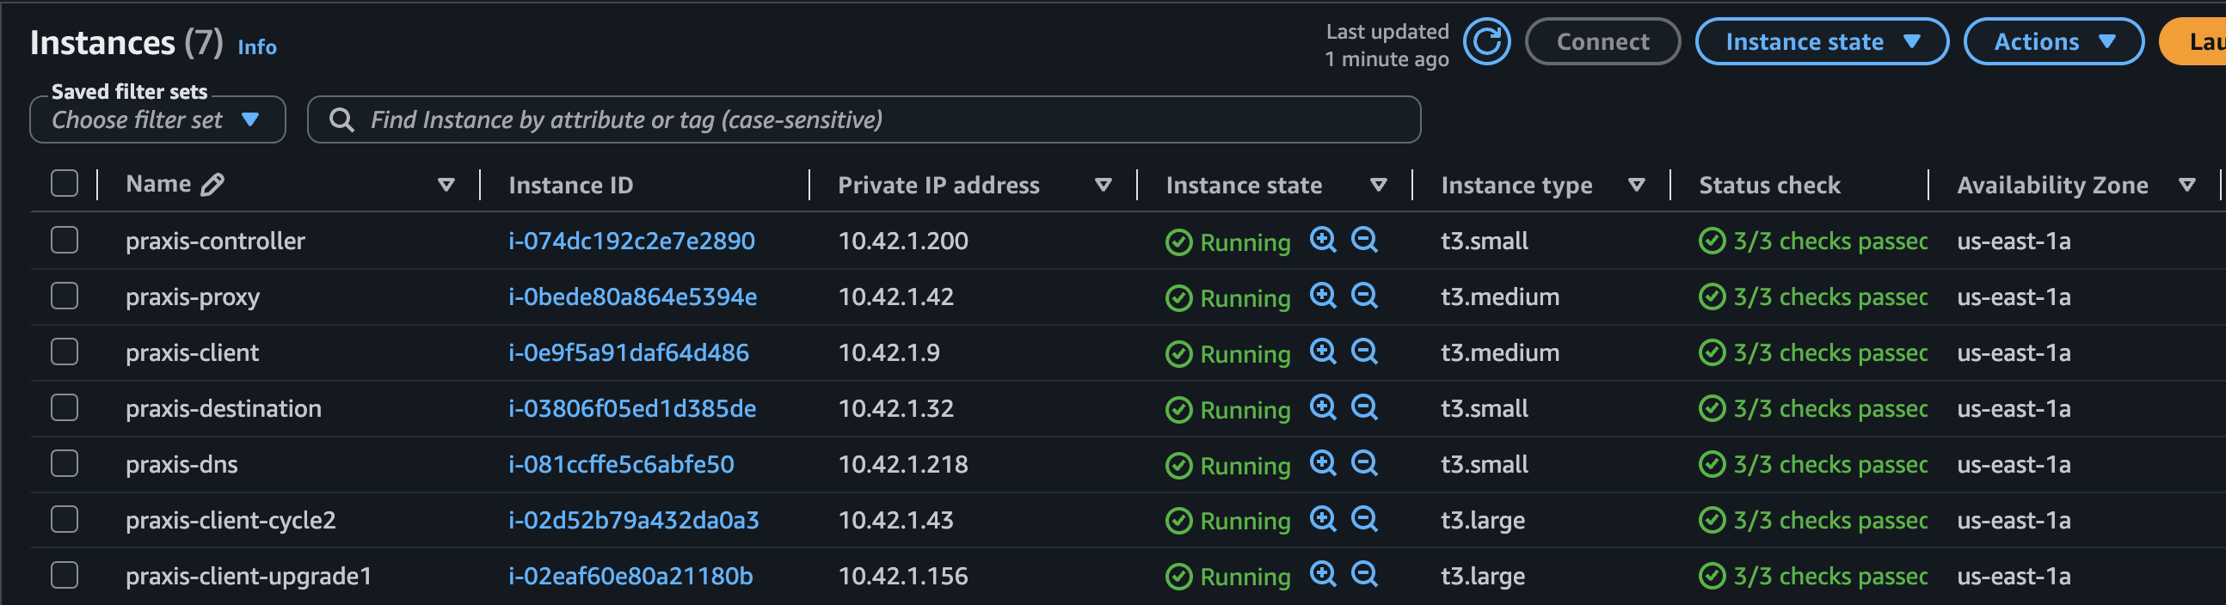

Phase 3 — Tooling
Purpose:
Prepare experiment tooling for automation, packet capture, feature extraction, scoring, and long-running jobs.
Installed and validated the tooling needed for browser sessions, Xray proxy operation, packet capture, and feature extraction.
Important tools:
Curl- s a command-line tool used to send and receive data from servers using URLs. It is commonly used for HTTP/HTTPS testing, API calls, downloading files, checking headers, testing authentication, and validating whether a web service is reachable. Officially, curl supports many protocols, including HTTP, HTTPS, FTP, SFTP, SMTP, and others.
Gzip compresses and decompresses files. It is often used for logs, packet captures, exported data, and large text files. GNU gzip documentation describes it as a tool for compressing and decompressing data.
Important point: gzip compresses individual files. It does not package multiple files into one archive by itself.
Tcpdump is a packet capture and packet inspection tool. It captures network traffic from an interface and can display packet summaries or save packets to a .pcap file for later analysis. The tcpdump manual describes it as printing packet contents that match a filter expression, with options to write captures to a file or read them back later.
python3 runs the Python 3 interpreter. It can execute scripts, run one-line commands, or open an interactive shell. Python’s official documentation states that the interpreter can read and execute commands interactively or execute a script passed as a file argument.
Tmux is a terminal multiplexer. It lets you run multiple terminal sessions inside one SSH session, detach from them, and reconnect later. The tmux documentation describes it as allowing multiple terminals to be created, accessed, and controlled from one screen, with sessions able to continue in the background after detaching.
sha256sum computes or verifies a SHA-256 hash for a file. GNU Coreutils documentation describes SHA-2 utilities, including sha256sum, as commands that compute checksums of different SHA-2 lengths.
Playwright in /opt/praxis/venv Playwright is a browser automation framework. It can control Chromium, Firefox, and WebKit browsers for testing or scripted interaction with web applications. The official Playwright Python documentation describes it as a browser automation tool for web applications and end-to-end testing.
Xray client scripts local scripts that interact with Xray Test Management, usually through Jira/Xray APIs. Xray’s documentation shows workflows where Playwright tests are run and test reports are pushed to Xray
browser runner scripts wrapper scripts used to launch browser automation tasks. In this context, they probably start Playwright, open a browser, run a predefined test, interact with a target web application, and collect results.

curl = quick HTTP/API testing from terminal
gzip = compress/decompress files
tcpdump = capture network traffic
python3 = run automation/scripts
tmux = keep multiple terminal sessions running
sha256sum = verify file integrity
Playwright = automate real browser behavior
Xray scripts = upload/report test results
browser runners = execute browser automation workflows
Achieved:
The system could generate browser sessions, capture pcaps, extract features, and run automated sweeps.
Problem found:
An early runner used system Python instead of the PRAXIS virtual environment.
That caused Playwright import errors.
Fix:
Patched runner to use /opt/praxis/venv/bin/python.
Why it mattered:
Without correct tooling and venv isolation, the formal experiments would not be reproducible.
What went well:
The toolchain was sufficient for automated candidate sweeps.
tmux made long-running phases manageable.

Phase 4 — Pilot experiments
Ran early pilot traffic sessions to confirm that browser sessions, pcaps, and logs were generated.
Purpose:
Verify that end-to-end traffic generation, browser logging, and pcap capture worked before formal experiments.
Completed:
Ran early browser/proxy pilot sessions.
Generated browser logs.
Generated pcaps.
Detected header-only pcap failure mode.
Achieved:
Confirmed the experiment path worked after fixing the Python environment.
What went well:
After the venv fix, browser success=true and pcaps were nonzero.
What went wrong:
The first pilot pcap was 24 bytes, which means pcap header only.
This was caused by the browser session failing before traffic generation.
Why it mattered:
Established the rule that header-only pcaps must be detected and excluded/rerun.

Phase 5 — RQ1 formal experiment: browser/profile camouflage
RQ1 tested browser profile versus proxy detectability.
Purpose:
Test whether browser-profile camouflage reduced proxy detectability.
Completed:
Compared default and camouflaged browser/profile conditions.
Earlier result:
camouflaged detection rate = 1.0
default detection rate = 1.0
Interpretation:
Browser profile camouflage alone did not reduce detectability in the original setup. Produced a clear negative result.
What went well:
Got a clear negative result. Browser camouflage alone did not solve detectability.
What went wrong:
A negative result alone is not a strong novelty contribution.
Why it mattered:
It showed that a static camouflage assumption was weak.
This later motivated adaptive selection.

Phase 6 — RQ2 formal experiment: multiplexing
RQ2 tested multiplexing condition versus identifiability.
Purpose:
Test whether static multiplexing conditions reduced identifiability.
Earlier result:
mux_off identifiability_rate = 1.0
mux_on_c2 identifiability_rate = 1.0
mux_on_c4 identifiability_rate = 1.0
mux_on_c8 identifiability_rate = 1.0

The initial mux configurations did not solve detectability or identifiability.
What went well:
Identified that naïve multiplexing was insufficient.
What went wrong:
The experiment treated mux as a static variable, not as an adaptive configuration space.
Interpretation:
Multiplexing had to be treated as part of an adaptive configuration space, not as a static yes/no variable.
Why it mattered:
This became the motivation for targeted c2/parallelism exploration in later phases.

Phase 7 — RQ3 formal experiment: DNS/decentralized-resolution setup
RQ3 was the DNS/decentralized-resolution resilience component.
Purpose:
Explore DNS-blocking and decentralized-resolution resilience.
What it supports:
DNS-blocking and decentralized resolution are part of the resilience layer.
Completed:
Initial DNS/RQ3 concept defined.
Basic DNS checks performed.
DNS service behavior required more focused validation.
Earlier Cycle 2 sessions used IP URLs, so resolver labels did not prove DNS behavior.
Completed:
Initial DNS/RQ3 concept defined.
Basic DNS checks performed.
Identified that RQ3 needed a hostname-based experiment.
Why it mattered:
This prevented a false claim that DNS/decentralized-resolution behavior had already been validated.
Phase 7 limitation:
Cycle 2 did not fully reintegrate RQ3 because DNS service reachability was not validated.
safe statement: RQ3 remains an integration path. Cycle 2 focused on the traffic-camouflage controller.
Later correction:
RQ3 was properly tested in Phase 21.

Phase 8 — Feature extraction
Extracted traffic features from pcaps.
Purpose:
Turn pcaps into vectors for detector scoring and public-benign distance scoring.
Core feature families:
pcap_size_bytes
packet_count
out_packets
in_packets
unknown_packets
out_payload_bytes
in_payload_bytes
total_payload_bytes
flow_duration_seconds
burst_count
first 20 signed packet lengths
What went well:
The feature structure became reusable across Phases 14-32.
Why it mattered:
This schema became the analytical backbone of PRAXIS.
It allowed detector scoring, public-distance scoring, mechanism analysis, and PCAP Analyzer reuse.

Phase 9 — Detector and statistical summary: Initial detector
Built a detector from earlier PRAXIS data.
Purpose:
Build an initial detector and quantify how detectable the original configurations were.
Original issue:
Most original tested configs were detected with probability or label near 1.0.
What went well:
This created an adversarial measurement target.
What went wrong:
The detector exposed that first-generation camouflage was weak.
Result:
Original configurations were mostly detected with high confidence.
Created a measurable adversarial target.
Why it mattered:
The detector revealed that first-generation camouflage was weak.
Later, the Adaptive Camouflage Controller optimized against this measurable objective.

Phase 10 — Baseline preservation
Preserved the original praxis-client and created an AMI/clone workflow before public-data work.
Purpose:
Preserve the original PRAXIS baseline before Cycle 2 modifications.
Created:
praxis-client-cycle2
instance_id = i-02d52b79a432da0a3
private_ip = 10.42.1.43
What went well:
Protected the original Phase 1–10 baseline.
Cycle 2 work was isolated from the original evidence machine.

Cycle 2 begins: the novel part - Adaptive Controller Work

Phase 11 — Public dataset ingestion
Purpose:
Add public benign traffic as an external baseline.
MAWI provides packet traces from the WIDE backbone and is suitable for public Internet traffic-shape baselining.

Downloaded MAWI/WIDE public traffic /opt/praxis/public_data/mawi/202403011400.pcap.gz
MAWI is useful because it provides WIDE backbone packet traces; the official MAWI page lists daily samplepoint-F traces, and a March 1, 2024, trace is a 15-minute tcpdump file with a 96-byte capture length and protocol breakdown.
https://mawi.wide.ad.jp/mawi/
https://mawi.wide.ad.jp/mawi/samplepoint-F/2024/202403011400.html

Created TCP samples:
/opt/praxis/public_data/sampled/mawi_202403011400_tcp_sample_200k.pcap
/opt/praxis/public_data/sampled/mawi_202403011400_tcp_sample_1m.pcap
What went well:
MAWI downloaded successfully.
gzip integrity check passed.
SHA256 manifest was created.
1M packet sample was created.
Why this matters:
Public benign traffic provides an external baseline. This changes PRAXIS from “my lab traffic only” to “lab candidate configs compared against public benign flow-shape distributions.”

The Adaptive Camouflage Controller with six modules.
Figure PRAXIS Adaptive Camouflage Controller workflow. The controller ingests public-benign traffic baselines and candidate proxy configurations, runs controlled sessions, captures traffic and logs, extracts PRAXIS traffic-shape features, computes detector confidence and public-distance scores, ranks configurations, and performs confirmatory reruns.

Figure summarizes the PRAXIS Adaptive Camouflage Controller. Rather than assuming a fixed camouflage strategy, PRAXIS evaluates candidate configurations empirically. Each configuration is executed in controlled sessions, converted into traffic-shape features, compared against detector and public-benign objectives, and ranked using a weighted multi-objective score. The selected configuration is then validated through confirmatory reruns.
PRAXIS turns camouflage selection into a measurement-guided controller problem.

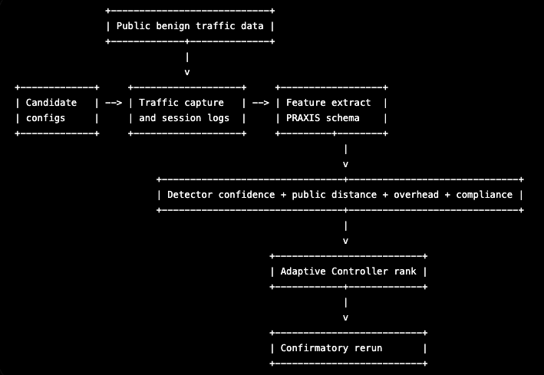

Phase 12 — Public benign feature model
Extracted public benign features from MAWI.
Purpose:
Convert MAWI public traffic into PRAXIS feature rows.
Key output:
/opt/praxis/public_data/features/mawi_public_flows_1m.csv
Observed:
10,288 public benign flow rows
10,289 CSV lines including header
Completed:
Extracted public benign flow-shape features.
Generated active MAWI public baseline CSV.
Result:
MAWI day 1 produced approximately 10,288 usable public benign flow rows.
Achieved:
Created the public-benign traffic envelope used by controller scoring.
Why it mattered:
Prevented the controller from selecting configurations that only reduce detector confidence while becoming obviously abnormal compared with public traffic.

Phase 13 — Candidate configuration sweep
Purpose:
Run formal Cycle 2 candidate configurations.
Tested 8 candidate configurations, 10 sessions each:
baseline_default_off
camouflaged_off
camouflaged_c2
camouflaged_c4
camouflaged_c8
default_c4
default_c8
camouflaged_c4_ddns
Result:
80 formal sessions
80 successful sessions
no header-only pcaps
What went well:
Automation worked.
All candidate configs completed successfully.
Why it mattered:
This was the first data source for the Adaptive Camouflage Controller.

Phase 14 — Initial controller scoring and correction.
Purpose:
Score candidate configurations using detector confidence and public-benign distance.
Completed:
Initial scoring pipeline.
Detected scoring flaw.
Corrected public-distance calculation.
Initial issue:
camouflaged_c8 appeared best, but detector probability remained 1.0.
But this was not reliable because:
mean_detector_proxy_probability remained 1.000000
Problem found:
public_z_distance was distorted by pcap_size_bytes.
The public MAWI file used sampled pcap size as a constant per public flow, while PRAXIS used per-session pcap size.
What went well:
The controller pipeline worked end-to-end.
What went wrong:
The first scoring method overweighted a bad feature in public-distance calculation.
Correction:
Phase 14B excluded pcap_size_bytes from public-distance scoring and kept it only as overhead.
Corrected Phase 14B result:
best_tradeoff_config_id = camouflaged_off
best_detector_config_id = camouflaged_c2
Interpretation:
camouflaged_c2 reduced detector confidence, but had worse overhead and public-distance penalty.

Phase 15 — First confirmatory rerun
Purpose:
Confirm early detector-reduction candidates.
Re-ran:
baseline_default_off
camouflaged_off
camouflaged_c2
Each with 30 sessions:
90 total sessions
90 successful sessions
Result:
baseline_default_off:
detector_probability = 0.996500
score = 0.573562
--
camouflaged_c2:
detector_probability = 0.940000
detector_delta = -0.056500
score = 0.676499
Interpretation:
camouflaged_c2 reduced detector confidence by 5.67%, but still lost on multi-objective score because overhead and public-distance penalties were too high.
What went well:
This confirmed a real detector-confidence reduction.
What was insufficient:
It did not beat baseline overall.
Camouflaged_c2 lost on corrected score due to overhead and public-distance penalties.
Why it mattered:
It showed camouflaged_c2 had promise but needed targeted improvement.

This motivated Phase 16.

Phase 16 — Targeted C2 candidate expansion
Expanded around the promising c2 mechanism.
Purpose:
Search around the c2 mechanism and browser-side parallelism.
Candidate set included:
baseline_default_off
camouflaged_off
default_c2_p1
default_c2_p2
camouflaged_c2_p1
camouflaged_c2_p2
camouflaged_c2_p3
camouflaged_c4_p2
Completed:
8 configurations
20 sessions each
160 total sessions
160 successful sessions
Collection:
160 sessions
160 successful sessions
no header-only pcaps
Scoring result:
best_tradeoff_config_id = camouflaged_c2_p1
best_detector_config_id = camouflaged_c2_p1
detector_probability = 0.487500
score = 0.360582
Against baseline:
detector_delta_vs_baseline = -0.512250
score_delta_vs_baseline = -0.217209
What went well:
This was the first strong result.
A configuration beat baseline on both detector confidence and corrected multi-objective score.
Important observation:
default_c2_p1 also performed strongly, suggesting that c2 multiplexing with parallel=1 may be the main mechanism.
Why it mattered:
Suggested that c2 multiplexing with parallel=1 was the key mechanism, not browser camouflage alone.

Phase 17 — Out-of-sample confirm-best rerun
Purpose:
Confirm the strongest Phase 16 candidates out of sample.
Completed:
baseline_default_off
camouflaged_c2_p1
default_c2_p1
50 sessions each
150 total sessions
150 successful sessions
Each with 50 sessions:
150 sessions
150 successful sessions
no header-only pcaps
Re-ran the strongest candidates:
baseline_default_off
camouflaged_c2_p1
default_c2_p1
Confirmed result:
baseline_default_off:
detector_probability = 1.000000
corrected_score = 0.654073

default_c2_p1:
detector_probability = 0.487000
corrected_score = 0.432949

delta:
detector_delta = -0.513000
score_delta = -0.221124
Final interpretation:
default_c2_p1 is the best confirmed configuration.
The improvement is likely driven primarily by c2 multiplexing with parallel=1, not browser camouflage.
Why it mattered:
This is the main PRAXIS result.
It demonstrates adaptive selection and out-of-sample confirmation.

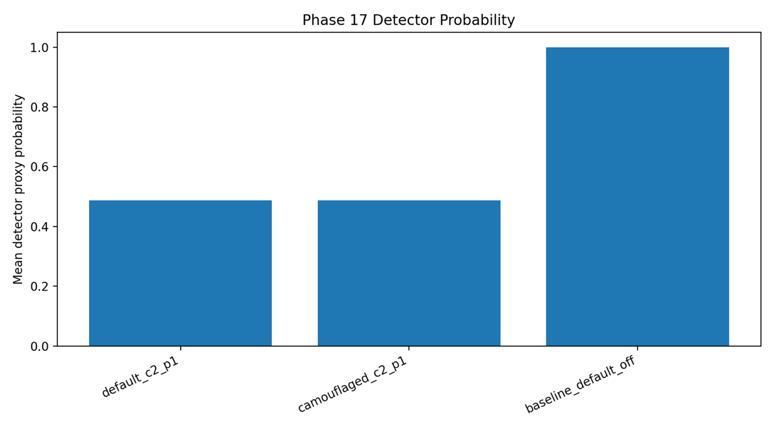

Figure. Phase 17 detector probability by configuration. The baseline configuration received mean detector probability 1.000, while the controller-selected configuration default_c2_p1 reduced mean detector probability to approximately 0.487 while preserving session compliance.
This figure compares detector confidence across final confirmatory configurations, usually:
baseline_default_off
camouflaged_c2_p1
default_c2_p1
The most important comparison is:
baseline_default_off = 1.000
default_c2_p1 = 0.487
Why it matters: This is the central empirical result of the dissertation.
It shows that the Adaptive Camouflage Controller selected a configuration that reduced detector confidence by:
- 0.487 = 0.513 or: 51.3 percentage points
Figure presents the primary confirmatory result. In Phase 17, the baseline configuration was assigned mean proxy probability 1.000 by the detector, indicating maximum detector confidence. The selected configuration, default_c2_p1, reduced mean detector probability to 0.487. This confirms detector-confidence reduction relative to baseline in an out-of-sample rerun. The configuration reduced detector confidence.
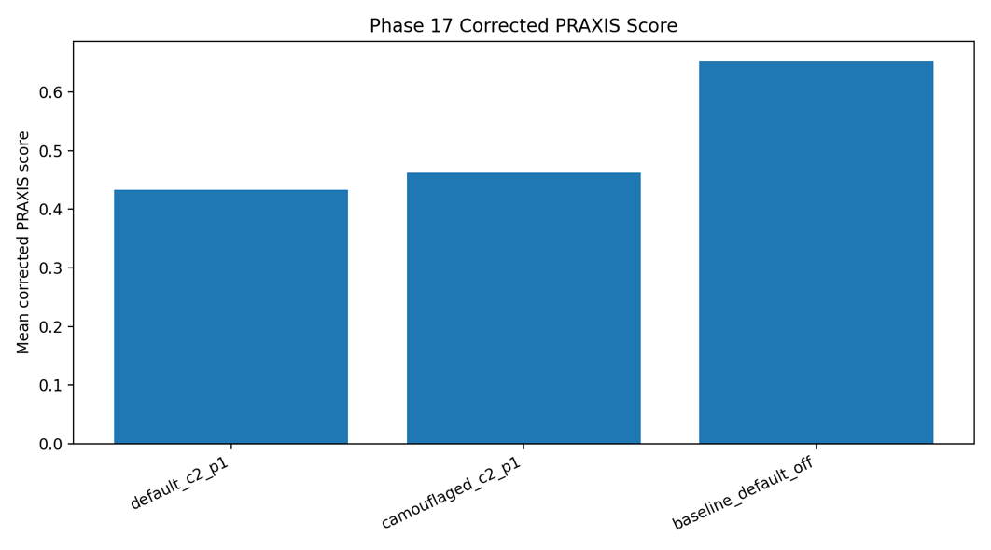

Figure Phase 17 corrected PRAXIS score by configuration. The controller-selected configuration default_c2_p1 improved the corrected multi-objective PRAXIS score relative to baseline by combining lower detector confidence, lower overhead, preserved compliance, and public-distance scoring.
figure shows, this figure compares the corrected PRAXIS score across Phase 17 configurations.
Important values:
baseline_default_off score = 0.654
default_c2_p1 score = 0.433
score delta = -0.221
Why it matters: Detector probability alone is not enough. A configuration could reduce detector confidence while becoming expensive, abnormal, or nonfunctional. This figure shows the overall tradeoff score improved.
Figure shows that the detector-confidence reduction did not come at the expense of the overall PRAXIS objective. The corrected multi-objective score improved from 0.654 for the baseline to 0.433 for default_c2_p1. Because the score incorporates detector probability, public-benign distance, overhead, and compliance, this result supports default_c2_p1 as the best confirmed tradeoff configuration.

---

Intermediate analysis: Phase 10 - 17
What went well from phase 10-17.
The strongest positives are:
1. Created a clean Cycle 2 EC2 clone instead of modifying the original baseline.
2. Added public benign traffic into the evaluation.
3. Moved from static experiments to a closed-loop controller.
4. Found and corrected the Phase 14 scoring flaw.
5. Ran out-of-sample confirmatory tests instead of stopping after candidate discovery.
6. Achieved a confirmed detector-confidence reduction from 1.000 to 0.487.
7. Compliance stayed at 100%.
8. Packaged final artifacts and hashes.

The most important win:
I did not simply report “everything is detected.” and found a configuration that materially reduced detector confidence and confirmed it out of sample.

What went wrong or needs improvement
1. Initial RQ1/RQ2 results were weak:
all original tested conditions had detectability or identifiability near 1.0.

2. Browser camouflage alone did not help enough:
camouflaged_off did not reduce detector probability.

3. Initial Phase 13 pilot failed:
runner used system python3 instead of /opt/praxis/venv/bin/python.

4. Initial Phase 14 scoring was flawed:
pcap_size_bytes distorted public-distance scoring.

5. Phase 15 was only a partial success:
camouflaged_c2 reduced detector confidence but lost on overhead and public-distance score.

6. DNS/RQ3 was not fully reintegrated:
DNS service check showed refused/no response, so decentralized-resolution integration remains future work.

7. Current result is lab-bound:
It does not prove real-world censorship evasion.

8. Detector robustness still needs more work:
Phase 20 should test a fresh holdout detector or retrained detector not used during controller selection.

The project improved because errors were discovered and corrected. The strongest final result came only after the controller was corrected and after candidate expansion around the mechanism.

Where the novelty is:
The novelty is not “a new proxy protocol.” The novelty is the adaptive controller framework.
The Novelty claim:
PRAXIS introduces an Adaptive Camouflage Controller that selects proxy/browser/multiplexing configurations by jointly optimizing detector confidence, public-benign traffic distance, compliance, and overhead.
Formal version:
The PRAXIS Adaptive Camouflage Controller is a closed-loop configuration-selection system that evaluates candidate circumvention configurations against lab-generated proxy sessions and public benign traffic distributions, then selects configurations that minimize detector confidence and benign-distribution distance while preserving compliance.

Specific novelty components:
1. Public benign traffic envelope:
MAWI/WIDE public traffic is used to define a benign flow-shape reference, not just lab data.

2. Closed-loop candidate selection:
PRAXIS does not assume one static camouflage configuration. It evaluates, scores, selects, and reruns.

3. Multi-objective scoring:
The score combines detector probability, public-distance, compliance penalty, and overhead.

4. Confirmatory rerun:
Candidate discovery and confirmation are separated.

5. Mechanism discovery:
Phase 17 suggests c2 multiplexing with parallel=1 is the main factor, not browser profile camouflage.

6. Negative-result handling:
The framework can show when a candidate reduces detection but fails overhead/public-distance constraints.

Praxis-safe novelty statement:
The contribution is a measurement-guided adaptive configuration-selection framework for censorship-circumvention traffic, validated with public benign traffic baselines and out-of-sample confirmatory reruns.

Main results table
Phase | Purpose | Main result
Phase 9 | Initial detector | Original configs mostly detected at 1.0
Phase 11–12 | Public benign model | MAWI 1M sample produced 10,288 benign flows
Phase 13 | Candidate sweep | 80/80 sessions successful
Phase 14B | Corrected controller scoring | camouflaged_c2 reduced detector but not score
Phase 15 | Confirmatory rerun | camouflaged_c2 detector 0.940, but score worse
Phase 16 | Targeted expansion | camouflaged_c2_p1 detector 0.4875, score better
Phase 17 | Confirm-best rerun | default_c2_p1 detector 0.487, score 0.432949

Final result:
default_c2_p1:
detector probability reduced from 1.000000 to 0.487000.
corrected score improved from 0.654073 to 0.432949.
compliance remained 100%.

Short story:
1. My initial results were weak: all original configs were detected.

2. I changed the project direction from static camouflage testing to an Adaptive Camouflage Controller.

3. I created an isolated Cycle 2 EC2 clone so I did not damage the original baseline.

4. I ingested MAWI public traffic and built a public benign flow-shape model.

5. I ran a candidate sweep, corrected the scoring function, and confirmed that some configs reduced detector confidence but initially had too much overhead.

6. I expanded around the promising c2 multiplexing mechanism.

7. Phase 17 confirmed that default_c2_p1 reduced detector confidence from 1.0 to 0.487 while preserving 100% compliance.

8. This supports a lab-measured adaptive-controller contribution, not a real-world deployment claim.

9. The next work is mechanism validation, external public-baseline validation, and holdout detector robustness.

PRAXIS Cycle 2 validates the Adaptive Camouflage Controller as a measurement-guided configuration-selection framework. In out-of-sample confirmatory testing, the controller-selected configuration default_c2_p1 reduced classifier proxy-confidence from 1.000 to 0.487 while maintaining 100% session compliance and improving the corrected multi-objective PRAXIS score from 0.654 to 0.433. The evidence suggests the main mechanism is c2 multiplexing with parallel=1, not browser camouflage alone. This is a lab-measured detector-confidence reduction under the PRAXIS threat model, not a claim of real-world censorship evasion deployment.

---

Phase 18 — Mechanism analysis
Purpose:
Identify which observable traffic features changed between baseline_default_off and default_c2_p1. Explanation why default_c2_p1 worked.
Role:
Phase 18 supports the explanation for why default_c2_p1 changed detector confidence.
What it contributes:
- Feature-delta reports.
- Mechanism explanation.
- Evidence that the winning configuration changed observable flow shape.
Boundary:
Feature changes support mechanism interpretation, but should not be overclaimed as universal causality.
Completed:
Feature-delta analysis between baseline and selected configurations.
Achieved:
Initial evidence that default_c2_p1 changed flow shape.
Why it mattered:
Prepared the path for stronger mechanism analysis in Phase 29.

Phase 19 — External public-benign validation (Second MAWI dataset baseline)
Purpose:
Add a second public-benign baseline.
Dataset:
Second MAWI/WIDE samplepoint-F day.

Completed:
Downloaded second MAWI day.
Sampled 1M TCP packets.
Extracted public benign features.
Result:
MAWI day 2 rows = 10,408
CSV lines including header = 10,409
Achieved:
Added public-baseline diversity.
Why it mattered:
Supported fresh holdout detector training and external validity.

Phase 20 — Holdout detector robustness
Purpose:
Test whether default_c2_p1 remains lower-confidence under fresh detectors.

Train fresh holdout detectors using Phase 13/16 proxy sessions and the second MAWI public-benign baseline, then evaluate Phase 17 confirm-best sessions.

Completed:
strict_unseen detector
baseline_known detector
Phase 17 sessions excluded from training
second MAWI baseline used as public benign negative source

Strict unseen result:
baseline_default_off mean_probability = 0.959737
default_c2_p1 mean_probability = 0.666053
delta_vs_baseline = -0.293684
Baseline-known result:
baseline_default_off mean_probability = 0.998023
default_c2_p1 mean_probability = 0.663093
delta_vs_baseline = -0.334930
Interpretation:
default_c2_p1 remained the lowest-confidence proxy configuration under two fresh holdout detectors.
Boundary:
At threshold 0.50, detection_rate remained 1.0 for all evaluated proxy configurations.
This confirms fresh-detector confidence reduction, not complete detector bypass.

Achieved:
Showed that default_c2_p1 advantage was not limited to the original detector.
Why it mattered:
Strengthened confidence-reduction claim while preventing overclaim of bypass.

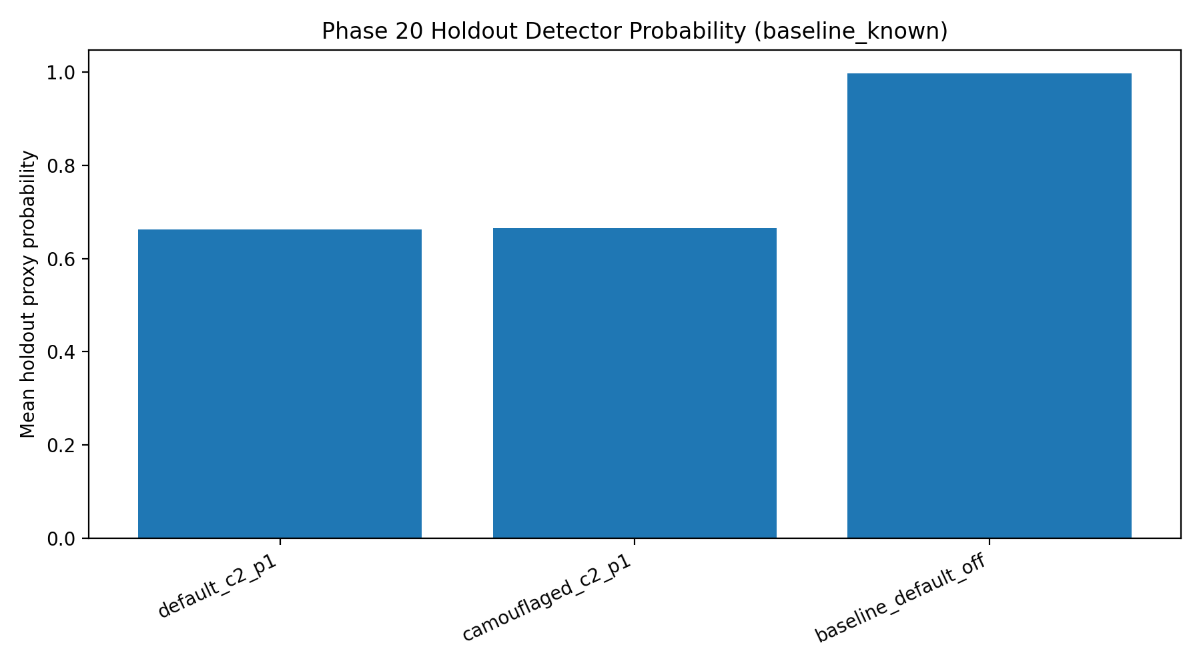

Phase 20B — Threshold validation
Purpose:
Check whether confidence reduction becomes binary detection-rate reduction under calibrated thresholds.

Evaluate Phase 17 configurations under fresh holdout detectors across public-FPR-calibrated thresholds.
Completed:
Threshold validation against public-FPR-calibrated thresholds.
Statistical validation of probability deltas.
Result:
Detector-confidence reduction remained statistically significant.
Binary detection rate remained positive under tested thresholds.
Interpretation:
Supported:
robust detector-confidence reduction

Not supported:
complete detector bypass
Praxis-safe statement:
The Adaptive Camouflage Controller produced a configuration that significantly reduced detector confidence under original and fresh holdout detectors while preserving compliance, but further work is needed for binary detector bypass.

Why it mattered:
This is a critical defense phase.
It makes the claim academically defensible.

Phase 21 — RQ3 resolver-independence integration
Purpose:
Test whether the selected traffic configuration could preserve access when DNS is blocked and an alternate decentralized-style resolution path is supplied.
Completed:
standard_dns_lab
dns_blocked
decentralized_resolution
30 sessions each
90 total sessions
Target:
hostname-based access to a controlled lab destination
Validated pattern:
standard_dns_lab:
n=30
success=30

dns_blocked:
n=30
success=0

decentralized_resolution:
n=30
success=30
Interpretation:
RQ3 is confirmed at the controlled resolver-independence level.
Boundary:
This validates controlled local decentralized-style resolution.
It does not prove production blockchain DDNS integration.
Why it mattered:
Completed the RQ3 in a bounded way.

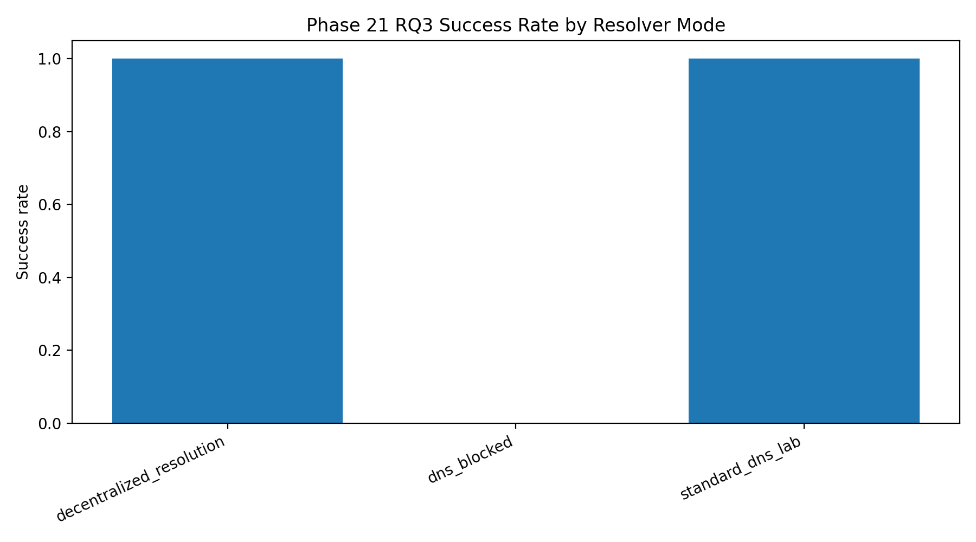

Figure Phase 21 resolver-mode success rates. Hostname-based access succeeded with lab DNS, failed when DNS was blocked without fallback, and succeeded again when decentralized-style local resolution was supplied.
Why it matters:This figure supports RQ3. It shows that:
the selected traffic configuration can preserve access when standard DNS is unavailable if alternate resolution supplies the hostname mapping.
Figure presents the controlled resolver-independence result. Standard lab DNS produced 30 successful sessions out of 30. DNS-blocked mode produced 0 successful sessions, confirming that hostname resolution was necessary. Decentralized-style local resolution restored success to 30 out of 30. This confirms RQ3 at the controlled resolver-independence level.

Phase 22 — Figures and tables
Purpose:
Convert PRAXIS Cycle 2 evidence into dissertation/advisor-ready reporting artifacts.
Included outputs:
- PRAXIS controller workflow.
- Phase 17 detector probability figure.
- Phase 17 corrected score figure.
- Phase 20 holdout detector robustness figures.
- Phase 20B threshold validation table.
- Phase 21 RQ3 resolver-mode success table.
- Research question status table.
- Claim-boundary table.
- Artifact manifest.
Role:
Phase 22 turns the experiment into presentable evidence for chapter writing, advisor review, and reproducibility.
Achieved:
Turned raw results into presentable evidence.
Why it mattered:
This made the work usable in chapters and slides.

Phase 23 — Chapter writing package
Purpose:
Prepare chapter-writing materials. Organize evidence into Praxis structure.
Uses:
- Introduction: final claims and research question table.
- Methods: configs, scripts, public-data manifests, feature extraction.
- Results: Phase 17, Phase 20/20B, Phase 21 reports and Phase 22 figures/tables.
- Limitations: claim boundary and threshold-validation limitations.
- Reproducibility appendix: manifests, hashes, sweep catalogs, scripts.
Role:
Phase 23 organizes the evidence into dissertation prose and reproducibility structure.

Phase 24 — PRAXIS Controller Service
Purpose:
Turn PRAXIS from a static experiment into a reusable research service.
Created components:
FastAPI API
Streamlit Controller Studio
shared PRAXIS core library
service README
systemd/tmux run patterns
Service idea:
The PRAXIS Controller Service operationalizes the Adaptive Camouflage Controller.
Researchers can load results, adjust weights, inspect rankings, view RQ status, and review claim boundaries.
Why this matters:
PRAXIS becomes a reusable tool instead of only a Praxis experiment.

Phase 25 — PCAP Analyzer Web App
Purpose:
Allow other researchers to upload their own pcaps and compute PRAXIS-compatible traffic-shape analysis.
Workflow:
uploaded pcap
→ extract PRAXIS traffic-shape features
→ compare against public-benign baseline
→ compute public-benign distance
→ compute overhead
→ use optional detector probability
→ compute partial/full PRAXIS score
→ export CSV/JSON/text report
Claim boundary:
Without detector probability or detector model, the analyzer produces a partial PRAXIS score only.
It does not claim detector-confidence reduction from a pcap alone.
Why this matters:
The PCAP Analyzer makes PRAXIS reusable beyond the original AWS experiment.
Researchers can plug in their own pcaps and produce PRAXIS-compatible artifacts.

Phase 26 — GitHub release
Purpose:
Package PRAXIS as a sanitized public research repository.
Repository:
https://github.com/zilantix/praxis
Included:
- PRAXIS Controller Studio.
- FastAPI API.
- Streamlit GUI.
- PCAP Analyzer page.
- reusable PRAXIS core library.
- sanitized example data.
- detailed README.
- ETHICS.md.
- SECURITY.md.
- LICENSE.
- docs and scripts.
Excluded:
- raw pcaps.
- private logs.
- credentials.
- GitHub tokens.
- AWS credentials.
- proxy secrets.
- full S3 archives.
- detector joblib models.
Claim boundary:
This GitHub release presents PRAXIS as a research and evaluation framework for adaptive configuration selection and detector-confidence analysis.
It does not claim complete detector bypass or real-world censorship evasion.

Phase 27 — Streamlit Cloud deployment
Purpose:
Deploy the PRAXIS Controller Studio as a public web app.
Required changes:
- Portable import paths.
- PRAXIS_DATA_DIR fallback to bundled examples.
- Streamlit Cloud config.
- packages.txt for external Linux dependency tcpdump.
- sanitized example data included in repository.
Main file path:
app/ui/praxis_dashboard.py
Role:
Phase 27 makes PRAXIS accessible as an interactive public demonstration.

Intermediate analysis #2: Phase 11 - 27
What Went Well from phase 11-27
- The project moved from static detection reporting to an adaptive controller.
- Public benign traffic was incorporated into the evaluation.
- The scoring flaw in Phase 14 was found and corrected.
- Candidate discovery and confirmatory testing were separated.
- default_c2_p1 reduced detector confidence from 1.000 to 0.487.
- Compliance remained 100%.
- Fresh holdout detectors confirmed lower confidence.
- RQ3 was confirmed at the controlled resolver-independence level.
- The work was converted into a reusable API, GUI, and PCAP Analyzer.
- The project was packaged for GitHub and Streamlit Cloud.

What Went Wrong or Required Correction from phase 11-27
- Initial RQ1/RQ2 experiments were weak because original configurations were detected.
- Browser camouflage alone did not solve detectability.
- An early pilot failed due to system Python being used instead of the PRAXIS virtual environment.
- Initial Phase 14 scoring was flawed because pcap_size_bytes distorted public-distance scoring.
- Phase 15 was only a partial success.
- Phase 20 confirmed confidence reduction, not binary detector bypass.
- Phase 21 initially required adjustment because previous sessions used IP URLs rather than hostname URLs.
- Public GitHub packaging required sanitization of secrets, private IPs, instance IDs, and raw pcaps.
- Streamlit Cloud required portable import paths and example-data fallbacks.

Intermediate Claim on phase 27.
PRAXIS Cycle 2 validates the Adaptive Camouflage Controller as a measurement-guided configuration-selection framework. In out-of-sample confirmatory testing, the controller-selected configuration default_c2_p1 reduced classifier proxy-confidence from 1.000 to 0.487 while maintaining 100% session compliance and improving the corrected multi-objective PRAXIS score from 0.654 to 0.433. Fresh holdout detectors confirmed lower confidence for default_c2_p1, although binary detection remained positive under tested thresholds. Phase 21 further confirmed controlled resolver independence under DNS-blocking conditions. These results support detector-confidence reduction and adaptive selection under the PRAXIS lab threat model, not complete detector bypass or real-world censorship evasion.

I already have enough for a strong defense, based on phase 27:
- Original negative result: static configs were detected.
2. Adaptive controller: built and tested.
3. Public-benign baseline: MAWI-derived traffic features.
4. Candidate sweeps: Phase 13, 16.
5. Confirmatory reruns: Phase 15, 17.
6. Strong result: default_c2_p1 reduced detector confidence from 1.000 to 0.487.
7. Compliance: 100%.
8. Fresh detector robustness: Phase 20/20B.
9. RQ3 controlled resolver-independence: Phase 21.
10. Figures/tables: Phase 22.
11. Web app/API/PCAP Analyzer: Phase 24–25.
12. GitHub release: Phase 26.
13. Streamlit deployment: Phase 27 in progress.

The current weakness is not that the research is weak. The weakness is that a committee can still ask:
Is the result specific to detector?
Is it specific to MAWI dataset?
Is it specific to one lab?
Why exactly did default_c2_p1 work?
Can another researcher reproduce this?
Is the app only a demo or a real reusable tool?

I decided to move forward with upgrades:
Upgrade 1: Stronger mechanism analysis
Upgrade 2: Multi-detector robustness
Upgrade 3: Second public dataset - MAWI + CICIDS external public-baseline validation
Upgrade 4: Formal threat model
Upgrade 5: Uniform statistics
Upgrade 6: Reproducibility appendix
Upgrade 7: External researcher workflow

I implemented them as:
Phase 28 — RHEL clone bootstrap and artifact verification
Phase 29 — mechanism and feature-importance analysis
Phase 30 — multi-detector robustness
Phase 31 — MAWI + CICIDS public-baseline integration
Phase 32 — formal algorithm, threat model, and reproducibility appendix
Phase 33 — external researcher workflow and final package

Upgrade 1 — Make mechanism analysis stronger
The result says default_c2_p1 worked. A Praxis explains why.
Add a mechanism chapter with:
feature deltas
feature importance
ablation analysis
detector contribution analysis
comparison between default_c2_p1 and camouflaged_c2_p1
Purpose:
The improvement is not random. It is tied to measurable changes in traffic-shape features caused by c2 multiplexing with parallel=1.
Deliverables:
phase18_feature_delta_report.csv
phase18_feature_delta_summary.txt
feature-importance plot
top-10 changed features table
mechanism explanation paragraph
Committee-safe claim:
Feature-delta and detector-importance analysis suggest that c2 multiplexing with browser-side parallelism set to 1 changes burst structure and packet-shape features in a way that lowers detector confidence.

Upgrade 2 — Add more detector families
Phase 20 helped, but for upgraded experiment I want detector diversity.
Add at least these model families:
Logistic Regression
Random Forest
Gradient Boosting / HistGradientBoosting
Linear SVM or calibrated SVM
k-NN or ExtraTrees as a secondary check
For each detector, report:
baseline probability
default_c2_p1 probability
delta
AUC
public false-positive rate
binary detection rate at calibrated thresholds
The strongest outcome is not necessarily bypass. The strongest defensible outcome is:
default_c2_p1 consistently lowers detector confidence across multiple classifier families.

Upgrade 3 — Add more public-benign baselines
Used MAWI and a second MAWI day. Added at least one more public baseline.
Minimum:
MAWI day 1
MAWI day 2
MAWI day 3 or different samplepoint
Stronger:
MAWI + CICIDS as sanity-check only
Not needed to redistribute raw public pcaps. Can be published only:
feature summaries
hashes
download instructions
small sample rows
The key table:
Public baseline | Rows | Winner | Score delta | Detector delta stable?
MAWI 2024-03-01 | 10,288 | default_c2_p1 | negative | yes
MAWI 2024-03-02 | 10,408 | default_c2_p1 | negative | yes
MAWI 2024-03-03 | TBD | default_c2_p1 | TBD | TBD
This strengthens external validity.

Upgrade 4 — Add formal threat model
The defense needs one threat-model slide/table.
Include:
Adversary:
observes traffic metadata and flow shape
uses classifier-based detection
does not decrypt payload
does not compromise endpoints
Defender:
can choose proxy/browser/mux/resolver configuration
can measure traffic in lab
wants compliance and lower detector confidence
Out of scope:
nation-scale active probing
TLS key compromise
endpoint compromise
real-world deployment guarantees
payload obfuscation claims
This prevents the committee from judging against an impossible threat model.

Upgrade 5 — Make statistics cleaner
Every result table should include:
n
mean
standard deviation
delta vs baseline
percent delta
95% bootstrap confidence interval
permutation p-value
claim interpretation
The tables should say:
default_c2_p1 reduced detector confidence by X with 95% CI [a, b], p < 0.001.
But also: binary detection remained positive under tested thresholds.

Upgrade 6 — Add a reproducibility appendix
To make reproduce the work by other researchers.
The appendix should include:
repository URL
commit hash
S3 artifact pointer
phase list
data sources
feature schema
config schema
commands
hashes
environment details
limitations
GitHub should contain:
README.md
docs/phases.md
docs/claim-boundary.md
docs/novelty.md
docs/research-questions.md
docs/threat-model.md
docs/methodology.md
docs/reproducibility.md
app/
examples/
scripts/
tests/

Upgrade 7 — Add external researcher workflow
PCAP Analyzer lets other researchers use PRAXIS. That is a strong novelty point.
Add a documented workflow:
1. Researcher runs their own proxy experiment.
2. Researcher captures pcaps.
3. Researcher uploads pcap to PRAXIS PCAP Analyzer.
4. PRAXIS extracts features.
5. Researcher supplies detector probability or detector output.
6. PRAXIS computes partial/full score.
7. Researcher exports CSV/JSON.
8. Researcher compares configurations.
This shows PRAXIS generalizes as a tool.
-----

Cycle 3

Phase 28 — AMI clone validation
Purpose:
Create a safe upgrade machine from AMI - praxis-client-cycle2.
Completed on:
praxis-client-upgrade1
Verification output:
phase14_sweep_features.csv OK
phase16_candidate_features.csv OK
phase17_confirm_features.csv OK
phase17_confirm_summary.txt OK
phase20_holdout_detector_summary.txt OK
phase20b_threshold_validation.txt OK
phase21_rq3_validation.txt OK
MAWI public baselines OK
/opt/praxis/app OK
Achieved:
Confirmed upgrade clone was ready.
Why it mattered:
Protected praxis-client-cycle2 as the confirmed result baseline.
Allowed final upgrades without risking original evidence.

Phase 29 — Upgrade 1: Mechanism analysis
Purpose: Explain why default_c2_p1 worked.
This phase explains why default_c2_p1 worked.
It produces:
feature deltas
effect sizes
logistic coefficients
random-forest importances
permutation importances
mechanism summary
Completed:
feature delta analysis
effect sizes
mechanism model
feature importance
feature-group ablation
Key feature changes:
flow_duration_seconds: -83.52%
packet_count: -21.85%
out_packets: -23.49%
in_packets: -20.15%
burst_count: -21.45%
pcap_size_bytes: -5.45%
Mechanism model:
logistic_auc = 1.000000
random_forest_auc = 1.000000
Achieved:
Strong evidence that default_c2_p1 changed traffic shape.
Why it mattered:
Strengthened RQ2 mechanism explanation.

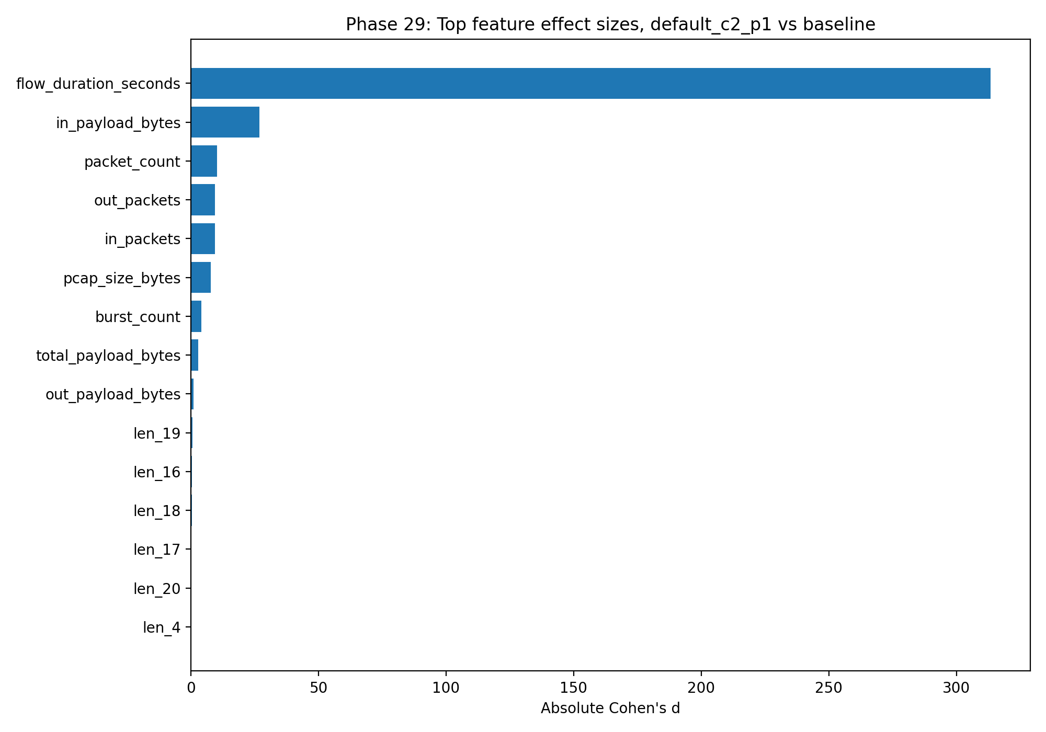
Figure Top traffic-shape feature effect sizes distinguishing default_c2_p1 from baseline. The selected configuration altered multiple observable flow-shape dimensions, including flow duration, packet counts, burst count, payload balance, and signed packet-length structure.
Why it matters: This figure explains why default_c2_p1 worked.
It supports the mechanism claim: c2 multiplexing with parallel=1 changed observable flow shape.
Figure provides mechanism evidence for RQ2. The selected configuration does not merely change a single feature; it changes several flow-shape dimensions. The largest differences include shorter duration, fewer packets, fewer bursts, and changes in payload and signed-length features. This supports the interpretation that c2 multiplexing with parallel=1 alters observable traffic structure in a way that reduces detector confidence.

Phase 29B — Artifact-control mechanism check
Purpose:
Check whether Phase 29 was only duration/count/pcap-size artifact.
Completed:
removed duration
removed packet counts
removed duration + counts
payload-only
signed-length-only
burst-only
Results:
no_duration AUC = 1.000000
no_packet_counts AUC = 1.000000
no_duration_no_counts AUC = 1.000000
payload_only AUC = 1.000000
signed_lengths_only AUC = 1.000000
burst_only AUC = 0.993400
Achieved:
Showed mechanism is not only duration, packet count, or pcap size.
Why it mattered:
Greatly strengthened the mechanism story.
Boundary:
This is mechanism separability, not proxy-vs-benign detector bypass.

Phase 30 — Upgrade 2 and 7: Multi-detector robustness
Purpose:
Test whether result holds across detector families.
Completed detectors:
logistic regression
random forest
extra trees
gradient boosting
calibrated linear SVC
Results:
random_forest:
delta = -0.381856
extra_trees:
delta = -0.156160
linear_svc_calibrated:
delta = -0.009679
gradient_boosting:
delta = -0.000287
logistic:
delta = +0.000482
Achieved: Showed detector-family-dependent robustness.
Interpretation:
Strong under tree-based detectors.
Marginal under calibrated linear SVC.
Negligible under gradient boosting.
Not supported under logistic regression.
Why it mattered:
Stronger than single-detector result.
Honest about detector-family limits.
Boundary:
No universal detector robustness.
No complete detector bypass.

Phase 31 — Upgrade 3: MAWI + CICIDS public-baseline sensitivity
Purpose:
Test whether default_c2_p1 remains favorable across public baselines.

CICIDS2017 is not the same kind of public Internet backbone baseline as MAWI. Used it as a secondary flow-feature sanity baseline. The dataset contains more than 80 network flow features extracted with CICFlowMeter. https://www.unb.ca/cic/datasets/ids-2017.html
The official MachineLearningCSV.zip obtained through the CIC/UNB download page, which is publicly available for researchers.

Completed:
mapped CICIDS2017 benign rows into PRAXIS-compatible schema
rescored Phase 17 across multiple baselines
CICIDS result:
mapped_benign_rows = 2,273,097
Public baselines tested:
cicids2017_mapped
mawi_day1
mawi_day2
mawi_day1_day2
mawi_plus_cicids_balanced
Result:
default_c2_p1 won under every tested public baseline.
Score deltas:
cicids2017_mapped: -0.301184
mawi_day1: -0.220701
mawi_day1_day2: -0.222451
mawi_day2: -0.220496
mawi_plus_cicids_balanced: -0.255280
Achieved:
Strong public-baseline sensitivity validation.
Why it mattered:
Showed that default_c2_p1 was not only an artifact of one MAWI sample.
Boundary:
MAWI remains primary.
CICIDS is secondary mapped sanity-check.

Phase 32 — Upgrades 6 and 8: Formal algorithm, threat model and reproducibility
Purpose:
Convert upgrades into defense-grade documentation.
Completed or intended deliverables:
final_upgraded_claim.md
algorithm.md
threat_model.md
reproducibility_appendix.md
external_researcher_workflow.md
phase32_hashes.sha256
phase32_completion.txt
Achieved:
Formalized the algorithm.
Formalized the threat model.
Documented reproducibility.
Documented external researcher workflow.
Created final upgraded claim.
Why it mattered:
A defense needs more than results. It needs method, threat model, reproducibility, and claim boundary.

---
The controller does not assume one camouflage strategy is always best. It measures candidate behavior, ranks candidates under explicit objectives, and confirms the selected configuration out of sample.
PRAXIS Threat Model
The modeled adversary can observe traffic metadata and flow-shape features.
The adversary may use classifier-based detection over non-payload traffic features such as:
- packet counts
- byte counts
- flow duration
- directional packet balance
- burst structure
- early signed packet lengths
Defender
The defender can choose proxy/browser/multiplexing/resolution configurations and evaluate them in a controlled lab.
The defender objective is not to prove undetectability. The objective is to reduce detector confidence while preserving compliance and avoiding excessive overhead.
In scope
- Controlled lab traffic measurement
- Non-payload traffic-shape analysis
- Detector-confidence reduction
- Public-benign feature comparison
- Fresh-detector robustness
- Controlled resolver-independence
Out of scope
- Complete detector bypass
- Real-world censorship evasion guarantees
- Nation-scale active probing
- Endpoint compromise
- TLS key compromise
- Payload inspection
- Deanonymization
- Production blockchain DDNS deployment
External Researcher Workflow
PRAXIS can be used by researchers who have their own traffic captures.
Minimal workflow
- Run a controlled proxy experiment.
- Capture pcaps for baseline and candidate configurations.
- Open PRAXIS Controller Studio or PCAP Analyzer.
- Upload each pcap.
- Enter the client/source IP.
- Enter the configuration label.
- Provide a success/failure label.
- Select or upload a public-benign baseline.
- Optionally provide detector probability.
- Export PRAXIS-compatible CSV and JSON reports.
Minimum recommended dataset
- baseline configuration: 30+ pcaps
- candidate configuration: 30+ pcaps
- public benign baseline: 5,000+ flows
- optional holdout detector
Interpretation
Without detector probability, PRAXIS can compute:
- traffic-shape features
- public-benign distance
- overhead
- compliance
- partial PRAXIS score
It cannot claim detector-confidence reduction without detector output.
----

Phase 33 — Upgrade 9: GitHub update and artifacts
Purpose:
Push final upgrade docs and Streamlit pages to GitHub.

What PRAXIS should claim now
Strong claim:
PRAXIS validates an Adaptive Camouflage Controller for measurement-guided proxy traffic configuration selection under a controlled cyber analytics threat model.
More detailed claim:
The controller-selected configuration default_c2_p1 reduced detector confidence from 1.000 to 0.487 while preserving 100% compliance and improving corrected PRAXIS score from 0.654 to 0.433. Mechanism analysis showed the effect is not solely explained by duration, packet count, or pcap size. Multi-detector testing showed detector-family-dependent confidence reduction, strongest under tree-based models. Public-baseline sensitivity testing showed default_c2_p1 remains the best-scoring configuration across MAWI and secondary CICIDS2017 mapped benign baselines. Phase 21 confirmed controlled resolver independence under DNS-blocking conditions.
Boundary:
PRAXIS does not prove complete detector bypass.
PRAXIS does not prove universal detector robustness.
PRAXIS does not prove real-world censorship evasion.
PRAXIS does not prove production blockchain DDNS.

Why this is strong for D.Eng defense
This is strong Doctor of Engineering work because it includes:
real cyber analytics problem
engineered solution
working prototype
multiple datasets
statistical evaluation
confirmatory testing
mechanism analysis
robustness analysis
threat model
reproducibility path
public research artifact
clear limitations

strongest novelty is:
PRAXIS turns proxy camouflage from a static configuration problem into an adaptive measurement-guided selection and validation problem.

Phase 34 inferential-statistics layer
Before Phase 34, PRAXIS already had strong descriptive and experimental evidence: repeated sessions, detector probabilities, corrected PRAXIS scores, compliance results,and public-baseline comparisons, and robustness checks.
Phase 34 converted those results into statistically supported evidence.
The key methodological decision in Phase 34 was to use session-level inference. Each PRAXIS session was treated as one independent observation. Individual packets were not treated as independent data points because packets inside a session are correlated. This was the correct statistical choice because it avoids artificially inflating the sample size.
Phase 34 applied several inferential methods:
bootstrap confidence intervals
permutation tests
Mann–Whitney U tests
Cohen’s d effect sizes
Cliff’s delta
Wilson confidence intervals for binary success rates
Fisher exact tests for resolver-mode success comparisons
Benjamini–Hochberg correction for feature-level tests

The main Phase 34 result confirmed the Phase 17 detector-confidence reduction inferentially. The detector probability decreased from:
baseline_default_off = 1.000
default_c2_p1 = 0.487
The mean difference was: delta = -0.513
The bootstrap 95% confidence interval was: [-0.514000, -0.511900]
The permutation test result was: p = 0.000100

This means the detector-confidence reduction was stable across session resampling and unlikely to be explained by random session variation. In dissertation wording, this supports the claim that default_c2_p1 significantly reduced detector confidence relative to baseline_default_off under the PRAXIS lab threat model.
Phase 34 also tested the corrected PRAXIS score. The corrected score improved from:
baseline_default_off = 0.654073
default_c2_p1 = 0.432949

The score difference was: delta = -0.221124
The bootstrap 95% confidence interval was: [-0.254584, -0.187908]

This interval is entirely negative, meaning the score improvement remained stable under resampling. Because lower PRAXIS score is better, this result supports the conclusion that default_c2_p1 was not only lower-confidence to the detector but also a better multi-objective configuration.
Phase 34 also confirmed compliance. All final Phase 17 configurations achieved:
50/50 successful sessions
100% compliance

This matters because PRAXIS does not select configurations that reduce detector confidence but break functionality. The selected configuration remained functional in every final confirmatory session.
The RQ3 resolver-mode inference also remained clear. Phase 34 summarized the Phase 21 resolver experiment:
standard_dns_lab: 30/30 success
dns_blocked: 0/30 success
decentralized_resolution: 30/30 success

This shows that standard DNS worked, DNS blocking caused failure, and decentralized-style local resolution restored success. The correct claim is controlled resolver independence, not production blockchain DDNS.
Phase 34 also summarized fresh-detector robustness from Phase 20. The strict-unseen detector showed:
baseline = 0.959737
default_c2_p1 = 0.666053
delta = -0.293684
95% CI = [-0.310496, -0.277289]
p = 0.000100

The baseline-known detector showed:
baseline = 0.998023
default_c2_p1 = 0.663093
delta = -0.334930
95% CI = [-0.349311, -0.320694]
p = 0.000100

These results support the conclusion that default_c2_p1 remained lower-confidence under fresh holdout detectors, not only under the original detector.
Phase 34 also incorporated the Phase 31 public-baseline sensitivity results. default_c2_p1 remained the best-scoring configuration across:
CICIDS2017 mapped benign baseline
MAWI day 1
MAWI day 2
combined MAWI day 1 + day 2
balanced MAWI + CICIDS baseline

This strengthened external-validity evidence. MAWI remains the primary public-benign baseline because it is packet-derived and closest to the PRAXIS feature schema. CICIDS2017 remains secondary because it is mapped from aggregate CICFlowMeter flow features.
Feature-level inference in Phase 34 also confirmed that the traffic-shape mechanism was substantial. The largest feature-level effects included:
flow_duration_seconds
in_payload_bytes
packet_count
out_packets
in_packets
pcap_size_bytes
burst_count
total_payload_bytes
out_payload_bytes
len_19

These results support the mechanism interpretation that default_c2_p1 changes multiple observable flow-shape dimensions, not just one feature.
The final result of Phase 34 is that PRAXIS now has inferential statistical support for its main claims. It supports:
detector-confidence reduction
corrected PRAXIS-score improvement
preserved compliance
fresh-detector confidence reduction
controlled resolver independence
public-baseline sensitivity robustness
feature-level mechanism evidence

----
https://praxis-controller.streamlit.app/

PRAXIS Adaptive Camouflage Controller Studio
The Controller tab is the core PRAXIS Adaptive Camouflage Controller demonstration.
It lets the user adjust objective weights and see which configuration wins. The code exposes four sliders: detector probability weight, public-benign distance weight, overhead weight, and compliance penalty weight. It then recomputes the ranking and displays the current winner.

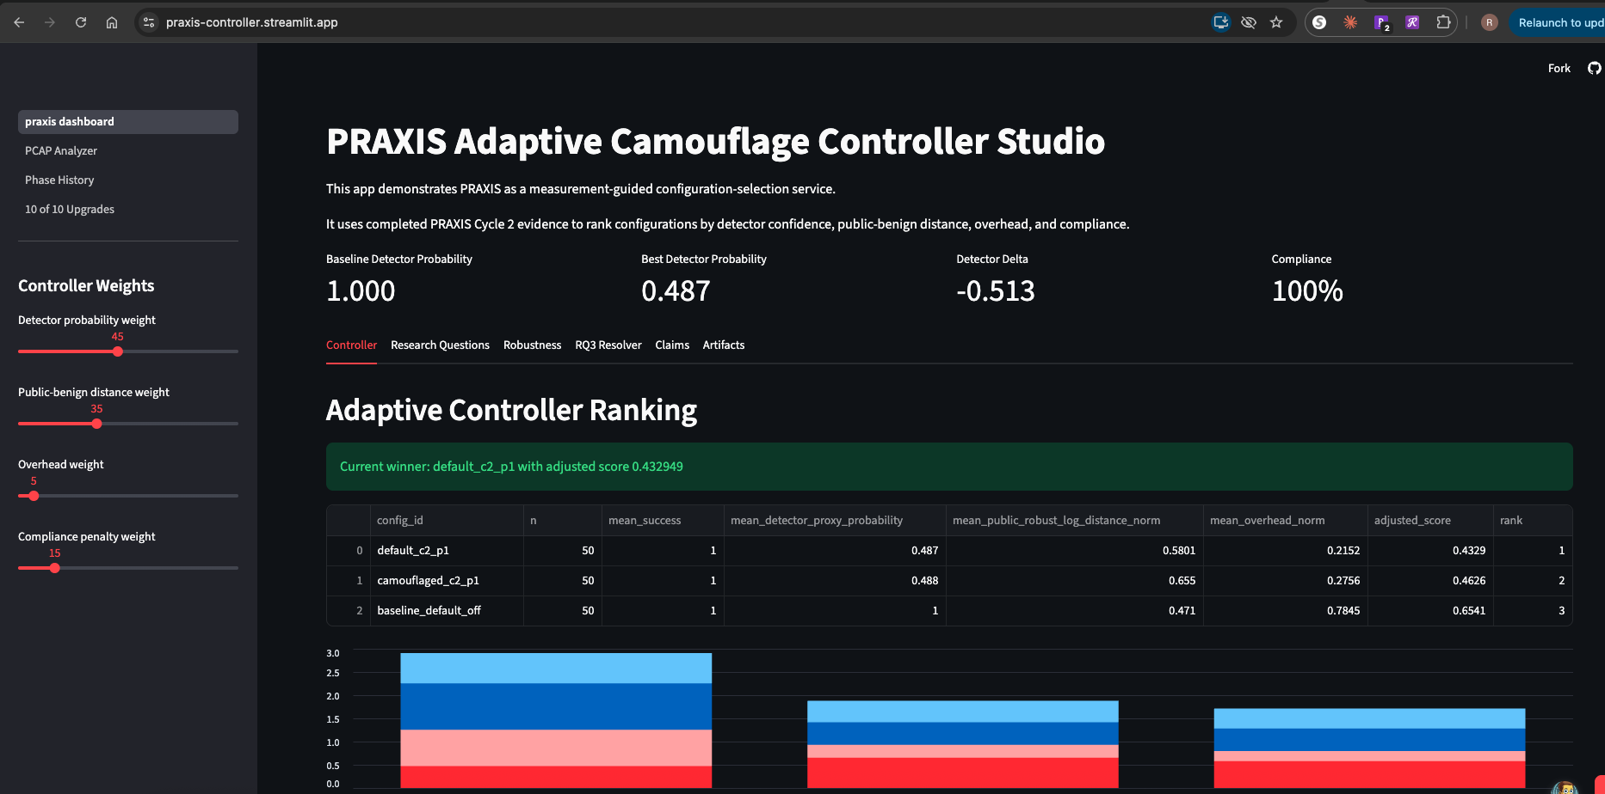

Controller weight fields
Field | Simple meaning | Technical meaning | Lower/higher effect
Detector probability weight | How much the controller should care about looking suspicious to the detector. | Weight applied to mean_detector_proxy_probability. | Higher value makes PRAXIS prefer configurations with lower detector probability.
Public-benign distance weight | How much the controller should care about looking like normal public traffic. | Weight applied to mean_public_robust_log_distance_norm. | Higher value makes PRAXIS prefer configurations closer to the public benign baseline.
Overhead weight | How much the controller should care about traffic cost. | Weight applied to mean_overhead_norm. | Higher value penalizes bulky or expensive configurations.
Compliance penalty weight | How much the controller should punish failed sessions. | Weight applied to compliance_penalty = max(0, 0.95 - mean_success). | Higher value strongly penalizes broken or unreliable configurations.

The score is computed as
adjusted_score = w_detector*detector_probability + w_public*public_benign_distance + w_overhead*overhead + w_compliance*compliance_penalty, where Lower score is better.

Controller ranking table
Field | Simple meaning | Technical meaning | How to interpret
rank | Position in the controller ranking. | Sort order after computing adjusted_score. | 1 is the current best configuration under the selected weights.
config_id | Name of the configuration. | Experimental condition label, such as baseline_default_off, default_c2_p1, or camouflaged_c2_p1. | This identifies which proxy/browser/mux setting is being scored.
n | Number of sessions tested. | Count of sessions used for that configuration. | Larger n gives stronger evidence. Phase 17 used n=50 per final config.
mean_success | Average session success. | Mean of session success labels. | 1.0 means 100% success.
mean_detector  _proxy_probability | Average detector confidence. | Mean probability assigned by the detector that sessions are proxy traffic. | Lower is better. This is main detector-confidence metric.
mean_public_robust  _log_distance_norm | Average normalized distance from public benign traffic. | Robust log-scaled distance to public benign baseline, normalized. | Lower means closer to public benign traffic.
mean_overhead_norm | Normalized overhead. | Normalized pcap/session-size cost. | Lower means less traffic overhead.
adjusted_score | Final controller score under current weights. | Weighted multi-objective score computed by the app. | Lower is better. The lowest score becomes the winner.

A low adjusted_score does not mean undetectable.
It means the configuration is the best tradeoff under the selected PRAXIS objectives.

Robustness tab. Phase 20 holdout detector table. The purpose is to answer: Did default_c2_p1 only work against the original detector OR does it remain lower-confidence under fresh detectors?
Field | Simple meaning | Technical meaning | Interpretation
mode | Holdout detector type. | Usually strict_unseen or baseline_known. | Indicates how the fresh detector was trained.
config_id | Configuration name. | Experimental condition label. | Compare baseline vs default_c2_p1.
n | Number of evaluated sessions. | Count of Phase 17 sessions for that config. | Usually 50 per config.
mean_holdout_  proxy_probability | Fresh detector confidence. | Mean probability from fresh holdout detector. | Lower than baseline means robustness.
std_holdout_  proxy_probability | Variability of probabilities. | Standard deviation across sessions. | Lower means more stable detector score.
detection_rate_050 | Binary detection rate at threshold 0.50. | Fraction of sessions with probability ≥ 0.50. | If 1.0, all sessions are still detected at 0.50.
mean_success | Average session success. | Mean compliance/success. | Should remain 1.0.
delta_vs_baseline or similar | Difference from baseline. | Candidate mean minus baseline mean. | Negative means lower detector confidence than baseline.

Phase 20B threshold-validation table

Field | Simple meaning | Technical meaning | Interpretation
mode | Detector mode. | strict_unseen or baseline_known. | Which fresh detector was used.
target_fpr | Target false-positive rate. | Desired public-benign false-positive rate. | Used to calibrate threshold.
threshold | Detector threshold. | Probability cutoff selected from public benign holdout data. | Higher threshold is stricter.
empirical_public  _fpr | Actual public false-positive rate. | Fraction of public benign flows above threshold. | Lower is better for avoiding collateral false positives.
config_id | Configuration being evaluated. | Baseline or candidate config. | Compare configs.
n | Number of sessions. | Count of evaluated sessions. | Usually 50.
mean_probability | Mean detector probability. | Average probability for that config. | Lower is better.
min_probability | Lowest session probability. | Minimum across sessions. | Shows best individual case.
max_probability | Highest session probability. | Maximum across sessions. | Shows worst individual case.
detection_rate_  at_threshold | Binary detection rate under calibrated threshold. | Fraction of sessions above threshold. | If still 1.0, no binary bypass.

PCAP Analyzer page
Field | Simple meaning | Technical meaning | What to enter
Upload .pcap or .pcapng | Upload packet capture. | Input file parsed by tcpdump -r. | A .pcap, .pcapng, or .cap file.
Client/source IP in pcap | Which IP is the client. | Used to determine packet direction: outbound vs inbound. | Example: 10.42.1.43 in lab, or the client IP in the uploaded pcap.
Session ID | Name for this analysis run. | Label written into output CSV/JSON. | Example: CUSTOM_SESSION_001.
Config ID | Configuration label. | Experimental condition name. | Example: default_c2_p1, baseline_default_off, or researcher’s custom config.
Session success | Whether the session worked. | Compliance label: 1 success, 0 failure. | Use 1 if the connection/session completed; 0 if it failed.
Overhead budget bytes | Expected acceptable session size. | Used to normalize pcap size into overhead_norm. | Default is 1,000,000. Increase for large captures.
Delete raw pcap after analysis | Privacy cleanup option. | Deletes uploaded pcap after feature extraction. | Recommended True for privacy.
Baseline source | Which public baseline to compare against. | Chooses server default or uploaded baseline CSV. | Use default for bundled PRAXIS baseline; upload for custom studies.
Upload public-benign baseline CSV | Custom baseline. | CSV containing PRAXIS-like public benign feature rows. | Use if analyzing outside PRAXIS lab or with another dataset.
I have detector probability for this pcap | Enables full score. | Tells app whether detector probability is available. | Check only if you have a valid detector score.
Detector proxy probability | Detector confidence. | Value from 0.0 to 1.0 indicating proxy probability. | Use actual detector output, not a guess.
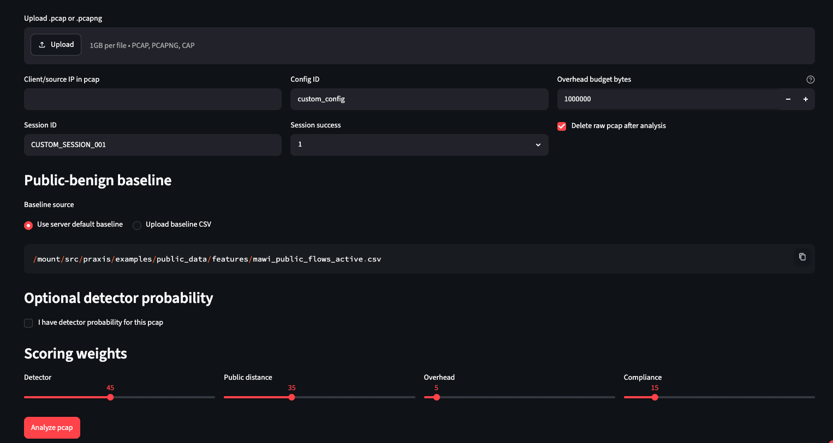

PCAP Analyzer output metrics
After analysis, the app shows headline metrics.
Field | Simple meaning | Technical meaning | Interpretation
Packets | Number of packets parsed. | packet_count. | Should be greater than zero.
Payload bytes | Total payload bytes. | out_payload_bytes + in_payload_bytes. | Measures useful data volume, not full Ethernet/IP overhead.
Public distance norm | Normalized distance from public benign traffic. | public_robust_log_distance_norm. | Lower means closer to selected public benign baseline.
PRAXIS score | Partial or full score. | Weighted PRAXIS score. | Lower is better.

GLOSSARY
- Adaptive controller — A system that does not assume one static configuration is best. Instead, it evaluates candidate configurations, scores them, selects the best compliant tradeoff, and confirms the result out of sample.
- Camouflage — In PRAXIS, camouflage means changing observable traffic-shape behavior so that proxy traffic receives lower detector confidence or better multi-objective score. It does not mean invisibility or guaranteed bypass.
- Traffic-shape features — Metadata-derived features from packet captures, such as packet counts, byte counts, flow duration, burst count, and signed packet lengths. These features do not require payload reconstruction.
- Non-payload analysis — Analysis based on packet metadata and flow shape rather than decrypted payload. PRAXIS operates in this boundary.
- Non-timing fingerprinting — Detection based on features other than exact packet timing. PRAXIS focuses heavily on packet counts, directions, payload sizes, burst structure, and packet-length patterns.
- Detector-confidence reduction — The central confirmed PRAXIS result. It means the detector assigned lower proxy probability to the selected configuration than to baseline.
- Complete detector bypass — A stronger claim that binary detection falls to zero or near zero under a defined threshold. PRAXIS does not claim this.
- Universal detector robustness — A claim that the configuration works against all detector families. PRAXIS does not claim this. Phase 30 showed detector-family-dependent results.
- Controlled lab threat model — The bounded environment in which PRAXIS results are valid. It includes controlled client/proxy/destination/DNS roles and does not claim real-world deployment success.
- Real-world censorship evasion — A broad operational claim that a tool bypasses actual censorship systems. PRAXIS does not claim this.
- Production blockchain DDNS — A real deployed blockchain/decentralized DNS system. PRAXIS Phase 21 validated controlled decentralized-style resolution, not production blockchain DDNS.
- Measurement-guided selection — The principle that configurations are selected based on measured evidence, not assumptions.
- Configuration-selection framework — The reusable method PRAXIS provides for testing and ranking proxy configurations.
- Research artifact — The code, data, scripts, reports, app, and documentation that make PRAXIS reproducible and usable by other researchers.
- Engineering artifact — The practical system you built: FastAPI service, Streamlit dashboard, PCAP Analyzer, GitHub repo, S3 archive, and repeatable scripts.
- Claim boundary — The explicit statement of what PRAXIS does and does not prove. This is critical for defense.
- AWS lab — The controlled cloud environment used to run PRAXIS experiments.
- EC2 instance — A virtual machine in AWS used to run PRAXIS components.
- PRAXIS controller — The analysis/control role that manages scripts, scoring, and artifacts. Not necessarily the same as the app controller.
- PRAXIS client — The experiment role that generates traffic, runs browser/curl sessions, captures traffic, and stores artifacts.
- PRAXIS proxy — The proxy server role used in controlled proxy traffic experiments.
- PRAXIS destination — The destination server that the client accesses through the proxy.
- PRAXIS DNS/resolution node — The DNS/resolution role used for RQ3-style experiments.
- praxis-client-cycle2 — The main Cycle 2 working instance. It preserved the original baseline while allowing Cycle 2 adaptive-controller work.
- praxis-client-upgrade1 — The AMI-launched upgrade clone used for 10-of-10 defense-readiness upgrades, including Phases 28–32.
- AMI — Amazon Machine Image. A snapshot-like image used to launch new EC2 instances with the same software and file structure.
- AMI clone — A new EC2 instance launched from an AMI of another instance. You used this to create praxis-client-upgrade1.
- SSM Session Manager — AWS Systems Manager feature used to access EC2 instances without SSH keys or public exposure.
- S3 — AWS object storage used to archive PRAXIS artifacts, datasets, reports, models, and current pointers.
- S3 current pointer — A small text file pointing to the latest timestamped artifact prefix. It prevents confusion when multiple timestamped uploads exist.
- Full artifacts current pointer — s3://praxis-logs-data/praxis/full-artifacts-current/CURRENT_POINTER.txt. Used for Phase 1–27 artifacts.
- S3 prefix — A folder-like path inside an S3 bucket.
- S3 archive — A .tar.gz file containing a packaged set of PRAXIS artifacts.
- S3 manifest — A file listing what was uploaded, hashes, scope, and artifact locations.
- AES256 encryption — Server-side encryption mode used for S3 uploads.
- EBS volume — AWS block storage attached to EC2. It stores /opt/praxis and other files.
- Root filesystem expansion — Growing the instance filesystem after increasing EBS volume size.
- RHEL instance — A Red Hat Enterprise Linux instance. You considered using it for portability validation but chose the AMI clone for faster upgrade work.
- GitHub repository — Public sanitized PRAXIS code repository: https://github.com/zilantix/praxis.
- Streamlit Cloud — Public app deployment service used for the PRAXIS Controller Studio.
- PRAXIS lab dataset — The controlled packet captures, logs, features, and labels generated by AWS lab.
- Treatment-labeled experiment data —PRAXIS lab sessions with known configuration labels and success labels.
- Public-benign dataset — External traffic data used to model normal traffic shape.
- Public-benign baseline — A feature distribution derived from public traffic, used to compute public-distance scores.
- Public-baseline sensitivity — Testing whether conclusions remain stable when the public-benign baseline changes.
- Dataset provenance — Documentation of where datasets came from, how they were processed, and their hashes.
- Dataset manifest — A file recording dataset hash, role, and processing status.
- SHA256 hash — Cryptographic hash used to verify file integrity.
- Mapped benign rows — Benign CICIDS rows converted into the PRAXIS feature schema.
- Packet-derived baseline — A baseline built from actual packet traces. MAWI is packet-derived.
- Aggregate-flow baseline — A baseline built from flow-summary CSVs. CICIDS is aggregate-flow.
- External validity — The degree to which results remain meaningful beyond one local dataset or lab condition.
- config_id — The label identifying a tested configuration.
- baseline_default_off — Baseline configuration using default browser profile and no c2-style selected multiplexing. It is the main comparison point.
- default_c2_p1 — Best confirmed PRAXIS configuration.
- camouflaged_c2_p1 — Camouflaged-browser comparison configuration using c2 and parallel=1.
- camouflaged_off — Camouflaged browser profile without c2-style multiplexing.
- camouflaged_c2 — Earlier c2 candidate with camouflaged browser profile.
- camouflaged_c4 — Candidate using camouflaged browser profile and c4 mux mode.
- camouflaged_c8 — Candidate using camouflaged browser profile and c8 mux mode.
- default_c4 — Default browser profile with c4 mux mode.
- default_c8 — Default browser profile with c8 mux mode.
- default_c2_p2 — Default browser profile, c2 mux mode, parallel=2.
- camouflaged_c2_p2 — Camouflaged browser profile, c2 mux mode, parallel=2.
- camouflaged_c2_p3 — Camouflaged browser profile, c2 mux mode, parallel=3.
- camouflaged_c4_p2 — Camouflaged browser profile, c4 mux mode, parallel=2.
- Browser profile — Browser automation profile used for sessions.
- default browser profile — Standard/default browser behavior.
- camouflaged browser profile — Modified browser behavior intended to appear less distinctive.
- mux_mode — Multiplexing mode used in the proxy/client transport.
- off mux mode — No selected c2/c4/c8 multiplexing mode.
- c2 mux mode — Multiplexing mode associated with the best PRAXIS result when combined with parallel=1.
- c4 mux mode — Higher multiplexing/parallel condition tested in candidate sweeps.
- c8 mux mode — Higher multiplexing/parallel condition tested in candidate sweeps.
- parallel — Browser-side or session-side parallelism setting.
- p1 — Parallelism set to 1.
- p2 — Parallelism set to 2.
- p3 — Parallelism set to 3.
- Why default_c2_p1 worked — It changed flow-shape behavior through c2 multiplexing with parallel=1, reducing detector confidence while preserving compliance.
- Padding mode — Whether artificial padding is added. In the confirmed best config, padding was none.
- Resolver mode — DNS/resolution mode used in an experiment.
- standard_dns_lab — Resolver mode where lab DNS resolves the hostname.
- dns_blocked — Resolver mode where DNS is blocked and no fallback is provided.
- decentralized_resolution — Controlled fallback mode where an alternate decentralized-style hostname mapping is supplied.
- Configuration sweep — Running multiple configurations for multiple sessions each.
- Candidate expansion — Adding more configurations near a promising mechanism.
- Confirmatory rerun — Running selected configurations again out of sample to confirm the result.
- Out-of-sample confirmation — Testing a selected configuration on new sessions not used during candidate discovery.
Feature-schema terms
- Feature schema — The set of columns PRAXIS extracts from pcaps and uses for scoring.
- session_id — Unique label for an experiment session.
- pcap_file — Path to the packet capture file.
- browser_log — Path to browser/session log file.
- success — Whether the session worked. 1 means success; 0 means failure.
- pcap_size_bytes — Size of the pcap file in bytes.
- packet_count — Number of packets parsed in the capture/session.
- out_packets — Number of packets where the client is the source.
- in_packets — Number of packets where the client is the destination.
- unknown_packets — Packets that cannot be classified as inbound or outbound relative to the client IP.
- out_payload_bytes — Total payload bytes sent by the client.
- in_payload_bytes — Total payload bytes received by the client.
- total_payload_bytes — Sum of outbound and inbound payload bytes.
- flow_duration_seconds — Time between first and last packet in the flow/session.
- burst_count — Approximation of traffic burst alternation or direction-change structure.
- len_1 through len_20 — First 20 signed packet payload lengths.
- Signed packet length — Packet length with direction encoded by sign: positive for outbound, negative for inbound, zero for unknown or missing.
- Payload length — Payload bytes recorded in packet metadata.
- Packet direction — Whether a packet is client-to-server or server-to-client.
- Burst structure — Alternation or grouping pattern of packet directions.
- Feature extraction — Process of converting a pcap into PRAXIS feature rows.
- Header-only pcap — A pcap file with only the file header and no captured packets, often 24 bytes. It indicates failed capture or no traffic.
- Traffic-shape row — One PRAXIS feature row describing one session or flow.
- Public feature row — A public-benign traffic feature vector, typically from MAWI or CICIDS mapping.
- Session-level feature table — CSV where each row corresponds to one session.
- Config-level score table — CSV where rows are aggregated by configuration.
Scoring and metric terms
- Detector probability — The detector’s probability that a session is proxy/circumvention traffic.
- mean_detector_proxy_probability — Average detector probability across sessions for a configuration.
- Detector confidence — Informal term for detector probability.
- Detector delta — Difference between candidate detector probability and baseline detector probability.
- Negative detector delta — Candidate has lower detector confidence than baseline. This is favorable.
- Public-benign distance — Distance between PRAXIS session features and public benign baseline features.
- Robust log distance — Distance computed after signed log transformation and robust scaling.
- public_robust_log_distance — Raw robust log-scaled public-benign distance.
- public_robust_log_distance_norm — Normalized public-benign distance.
- Public-distance delta — Difference between candidate public-distance and baseline public-distance.
- Overhead — Cost of a configuration, usually based on traffic volume or pcap size.
- overhead_norm — Normalized overhead.
- Compliance — Whether a session worked successfully.
- mean_success — Average success across sessions.
- Compliance score — Numeric success measure, usually 1.0 for success and 0.0 for failure.
- Compliance penalty — Penalty applied when compliance falls below threshold.
- PRAXIS score — Weighted multi-objective score combining detector probability, public-distance, overhead, and compliance penalty.
- Corrected PRAXIS score — Score after correcting the Phase 14 issue by excluding pcap_size_bytes from public-distance and using it as overhead.
- Lower score is better — PRAXIS scores are minimized.
- Partial PRAXIS score — Score without detector probability, used by PCAP Analyzer when no detector output is provided.
- Full PRAXIS score — Score including detector probability.
- Score type — Indicates whether the score is full_score or partial_score_no_detector.
- Detector weight — Weight applied to detector probability in the scoring function.
- Public-distance weight — Weight applied to public-benign distance.
- Overhead weight — Weight applied to overhead.
- Compliance weight — Weight applied to compliance penalty.
- Weighted scoring — Combining several objectives into a single score using weights.
- Multi-objective optimization — Optimizing more than one metric at once.
- Tradeoff configuration — Configuration selected because it balances detector confidence, public-distance, overhead, and compliance.
- Best detector configuration — Configuration that minimizes detector confidence, regardless of other costs.
- Best tradeoff configuration — Configuration with the best overall PRAXIS score.
- Public FPR — False-positive rate on public benign data.
- Target FPR — Desired false-positive rate used for threshold calibration.
- Empirical public FPR — Actual measured false-positive rate on public benign holdout data.
- Detection threshold — Probability cutoff used to convert detector probability into binary label.
- detection_rate_050 — Fraction of sessions detected at threshold 0.50.
- Threshold-calibrated detection rate — Detection rate after choosing threshold based on public benign FPR.
- Binary detection — Classifying traffic as proxy or benign using a threshold.
- Confidence reduction vs bypass — Confidence reduction means lower probability; bypass means binary label changes to benign. PRAXIS confirms the former, not the latter.
Machine-learning and robustness terms
- Detector — A model that estimates whether traffic is proxy/circumvention traffic.
- Original detector — The first detector built in earlier PRAXIS phases.
- Fresh detector — A new detector trained later to test whether the result generalizes beyond the original detector.
- Holdout detector — Detector evaluated on sessions excluded from training.
- Strict-unseen detector — Fresh detector trained without Phase 17 evaluation configurations.
- Baseline-known detector — Fresh detector that may know baseline behavior but excludes selected winning configs.
- Multi-detector robustness — Testing whether a result holds across multiple model families.
- Detector family — A class of model, such as logistic regression or random forest.
- Logistic regression — Linear classifier used as a detector family in Phase 30.
- Random forest — Tree-based ensemble detector. In Phase 30, it showed strong confidence reduction for default_c2_p1.
- Extra trees — Extremely randomized trees ensemble. In Phase 30, it also showed meaningful confidence reduction.
- Gradient boosting — Boosted-tree detector. In Phase 30, it showed negligible reduction.
- Calibrated linear SVC — Linear support vector classifier with probability calibration. It showed small/marginal reduction.
- AUC — Area under the ROC curve. Measures separation ability independent of a single threshold.
- Training AUC — AUC measured on training data.
- Accuracy — Fraction of correct binary predictions.
- Precision — Among positive predictions, how many were correct.
- Recall — Among true positives, how many were detected.
- F1 score — Harmonic mean of precision and recall.
- Public holdout — Public benign rows held out to evaluate false-positive behavior.
- Train/test leakage — When evaluation data appears in training. PRAXIS avoids this in holdout phases.
- Class imbalance — Unequal number of proxy and benign samples.
- Balanced class weight — Training option that compensates for class imbalance.
- Probability calibration — Converting model output into calibrated probabilities.
- Detector-family-dependent robustness —the effect is strong for some detectors, weak or absent for others.
- Universal detector robustness — A stronger unsupported claim that the result works across all detectors.
Statistical terms
- Delta — Difference between candidate and baseline.
- Percent delta — Delta expressed as percentage of baseline.
- Bootstrap confidence interval — Interval estimated by resampling sessions.
- 95% confidence interval — Range expected to contain the true effect under the bootstrap procedure.
- Permutation test — Statistical test that shuffles labels to estimate how likely the observed difference is by chance.
- Permutation p-value — Probability of seeing a difference at least as extreme under random label assignment.
- Mann–Whitney U test — Non-parametric test used in mechanism analysis for feature distributions.
- p-value — Probability of obtaining an effect as extreme under the null hypothesis.
- Cohen’s d — Standardized effect size measuring how far apart two means are in pooled standard-deviation units.
- Effect size — Magnitude of difference, not just statistical significance.
- Feature importance — Model-estimated contribution of a feature.
- Permutation importance — Feature importance measured by shuffling a feature and seeing performance drop.
- Ablation — Removing or isolating feature groups to test what drives performance.
- Feature-group ablation — Testing groups like payload-only, burst-only, or signed-length-only.
- Artifact-control check — Test to verify results are not only due to obvious artifacts like duration, pcap size, or packet count.
- Mechanism separability — Ability to distinguish baseline and selected configuration based on feature groups. Used for mechanism explanation, not bypass claim.
PCAP Analyzer terms
- .pcap — Packet capture file format.
- .pcapng — Newer packet capture file format.
- tcpdump -r — Command used to read pcap files.
- Client/source IP — IP address used to infer packet direction in PCAP Analyzer.
- Uploaded pcap — File supplied by a researcher to analyze.
- Public baseline CSV — Optional uploaded public-benign baseline for custom analysis.
- Detector probability input — Optional probability supplied by the researcher to compute a full PRAXIS score.
- Overhead budget bytes — User-defined pcap-size budget used to normalize overhead.
- PCAP Analyzer summary JSON — Machine-readable output describing extracted features and score.
- PCAP Analyzer features CSV — CSV containing raw extracted PRAXIS features.
- PCAP Analyzer scored CSV — CSV containing features plus public-distance, overhead, compliance, and PRAXIS score.
- PCAP Analyzer text report — Human-readable summary.
- Partial score warning — Warning shown when no detector probability is supplied.
- External researcher workflow — Documented process for researchers to use PRAXIS with their own captures.
GitHub and deployment terms
- Repository — GitHub project containing public PRAXIS code and docs.
- Commit — A saved change in Git.
- Push — Uploading local commits to GitHub.
- Rebase — Moving local commits on top of updated remote commits.
- Remote origin — GitHub repository URL configured in local Git.
- Branch ahead — Local repository has commits not yet pushed.
- Non-fast-forward rejection — GitHub rejected push because remote has commits not present locally.
- Fine-grained token — GitHub token scoped to a specific repo and permission set.
- Token exposure — A security incident where a token appears in chat, terminal, or repo. It must be revoked.
- Secret scan — Search for tokens, AWS keys, private keys, and other sensitive data.
- .gitignore — File excluding raw pcaps, credentials, and large sensitive files from Git.
- SECURITY.md — Public security policy and sensitive-data boundary.
- ETHICS.md — Responsible-use and research-boundary document.
- README.md — Main project description and user guide.
- docs/ — GitHub folder containing algorithm, claim boundary, novelty, phase history, threat model, and upgrade summaries.
- examples/ — Sanitized example data bundled for app demo.
- scripts/ — Public run scripts for API and UI.
- app/ — PRAXIS application source code.
- app/lib/ — Shared PRAXIS Python libraries.
- app/api/ — FastAPI backend.
- app/ui/ — Streamlit frontend.
- app/ui/pages/ — Streamlit subpages like PCAP Analyzer and Phase History.

